**SENDCo Update Spring Term 1 2025**

**Important Update: Transition to the Professionals Portal for EHCP Annual Reviews**

We are excited to announce some important changes regarding the submission of EHCP Annual Reviews.

Currently, review paperwork and amendments are sent directly to SES via email. However, Leicester City Council is in the process of transitioning to the Professionals Portal for the entire EHCP process. As a result, you will now upload all Annual Review paperwork directly to the Professionals Portal, rather than emailing it.

The updated portal will be available in Spring term 2. Please note that the EHCP.annual review email address will be deactivated after the roll out, and all Annual Review submissions must be made via the Professionals Portal from that date onward.

To help you prepare for this change, we will be creating training videos that can be accessed in your own time.

These changes are designed to streamline the EHCP process, ensuring that submissions are made and processed more efficiently in a timely manner. By consolidating all submissions into one platform, we will reduce the need for multiple email addresses and enable easier access to Draft, Final, and Amended EHC Plans.

Additionally, this will enhance support for Parents and Carers, allowing them to access paperwork and EHCP documents more quickly. They will also be able to track the progress of their children and young people throughout the process.

We look forward to seeing you at the training session!

**EYST – Dingley’s Promise – Early Years Inclusion Project**

Dingley’s Promise are on a mission to skill up the early year’s workforce through a comprehensive and extensive training offer and Leicester City is 1 of 31 Local Authorities across the country who are currently taking part. The training is free for the LAs who are taking part.

There are 10 courses in total which are all online so can be accessed flexibly. They are aimed at supporting confidence, skills and full of practical ideas. 6 courses are out now:

* + Introduction To Early Years Inclusive Practice
  + Early Years SEND Transitions
  + Managing Behaviours that Challenge
  + Having Difficult Conversations with Families
  + Voice of the child
  + Intersections within Early Years Practice.

More courses will be out soon.

We currently have 308 learners who have accessed this training across settings, schools and Leicester City Council see below – Leicester is green sitting in between Lambeth and Lincolnshire. The training is available to the whole early years workforce and a lot of it is relevant for key stage 1.

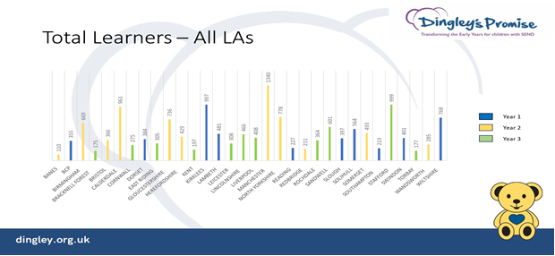

**Overall learner satisfaction for all courses is really positive across all the LAs**

* 99% feel more confident as a result of the training.
* 96% believe they can support more children.
* 99% would recommend this course.
* 99% are committed to making a change in their setting as a result of the training.

**Please sign up for this free training:**

* Register at <https://dingley.org.uk/dingleys-promise-training/early-years-inclusion-programme/>
* They willl get back to you within 5 working days to confirm next steps.
* Please allow about 6 hours to complete each course.
* For queries or support, please contact [training@dingley.org.uk](mailto:training@dingley.org.uk)

**High Needs Funding Block Recovery Management Plan and Transformation Project**

The vision of the plan is that there is equity in the distribution of resources to ensure all pupils are able to access support and provision to meet their needs and thrive in education.

The plan has been shared with The Children and Young Peoples’ Scrutiny Commission, SEND and AP Board, SENDSS Support services (Whole Service Meeting Oct 24) and colleagues in SES during their Team Meeting. It has also been presented to Schools forum. The plan will be shared at Primary Development Group (DGs) meetings this term. In March, there will be a Secondary Head Teachers Conference which will also share this plan. We will continue to share the plan with all stakeholders.

**Change Programme Partnership Updates:**

**Continuation of the SEND and AP Change Programme - Continuing Through 2024/25: Confirmed**

The DfE has committed to supporting the next phase of the programme. In LLR we will be continuing the following workstreams:

* Local Area Inclusion Plans (now Partnerships & Plans): Evolving to align with a shared vision for Inclusive Mainstream Practice
* Bands & Tariffs: SEND funding survey; Developing a through banding descriptor model from inclusive mainstream offer to specialist provision, and test and learn of tariffs.
* PINS: Supporting inclusion for neurodiverse children and young people
* ELSEC: Building on the successes of Speech and Language services.
* Alternative Provision (AP): Testing a three-tier outreach service to support schools and intervene effectively.
* Advice & Information: A new focus area added in September 2024
* APST/SAFE Approaches: Developing multidisciplinary 'team around the school” models to provide holistic support.

**New Workstreams for Phase Two:**

ND Inclusion Pathway: Developing a screening and support model for neurodiverse children, inspired by the Portsmouth model

SILLR Alliance: Preparing for a potential transition to a SEND & Inclusion LLR Alliance after the CPP end date

SEND Joint Commissioning Strategy: Refreshing our approach to joint commissioning across the partnership

**There is a potential extension of the Change Programme until March 2026**. The direction of the DFE Policy will shift to testing inclusive practices and outcomes at a local level, building towards a cohesive National Inclusion Framework

If approved, the extension would allow us to test an expanded package of reforms, focusing on the following:

* National Inclusion Service Principles to create a coherent framework for inclusion.
* Enhanced collaboration with schools, deep dives into inclusive practices, and joint commissioning approaches
* Full rollout of multidisciplinary Alternative Provision Specialist Taskforce models across all CPP local authorities

**Bandings and Tariffs**

Leicester City were successful in a bid for a Finance lead to work alongside the bandings and tariffs lead and sit within the Quality Inclusion Team. Nick Gilroy has been seconded to this role in a part-time capacity. Please use the emails below for any funding queries to ensure it is dealt with as promptly as possible.

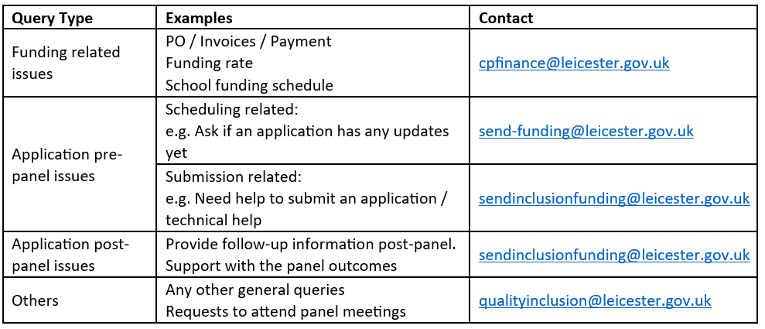

**SEND Funding Survey**

The Bandings and Tariffs reform (Change Programme) has a focus on establishing a better understanding of High Needs spending and existing best practice to support our children and young people with SEND.

In order to support the development of a national framework of banding and price tariffs, Leicester City Council has developed a SEND Funding Survey for settings, schools, colleges and LAs to give their view on SEND funding for our children and young people to be submitted to the DfE.

[A copy of the survey questions can be viewed here [pdf file]](https://schools.leicester.gov.uk/media/9445/send-funding-survey-spring-2025-survey-questions-to-support-schools.pdf)

QIT launched the survey on January 13 and it will remain open until **Monday 24 February 2025**

The survey has been created in collaboration with colleagues across the Early Years, Mainstream, Special schools, and finance sectors to give them a direct voice to the DfE on the barriers they are experiencing in relation to SEND funding. **Please can you complete the survey in collaboration with your senior leaders and business managers or equivalent so that your views are heard and shared.**

**PINs**

The LCI and SEMH team have been working collaboratively to develop training for the schools involved in the PINs project. There are 20 schools in the project who are receiving a range of training and in school support alongside working with the parent carer forum to establish parent coffee mornings.

**Alternative Provision**

As part of the Change Programme Partnership, LLR have agreed a three-tier model of Alternative Provision. This is in line with the Government’s SEND and AP improvement plan (March, 2023).

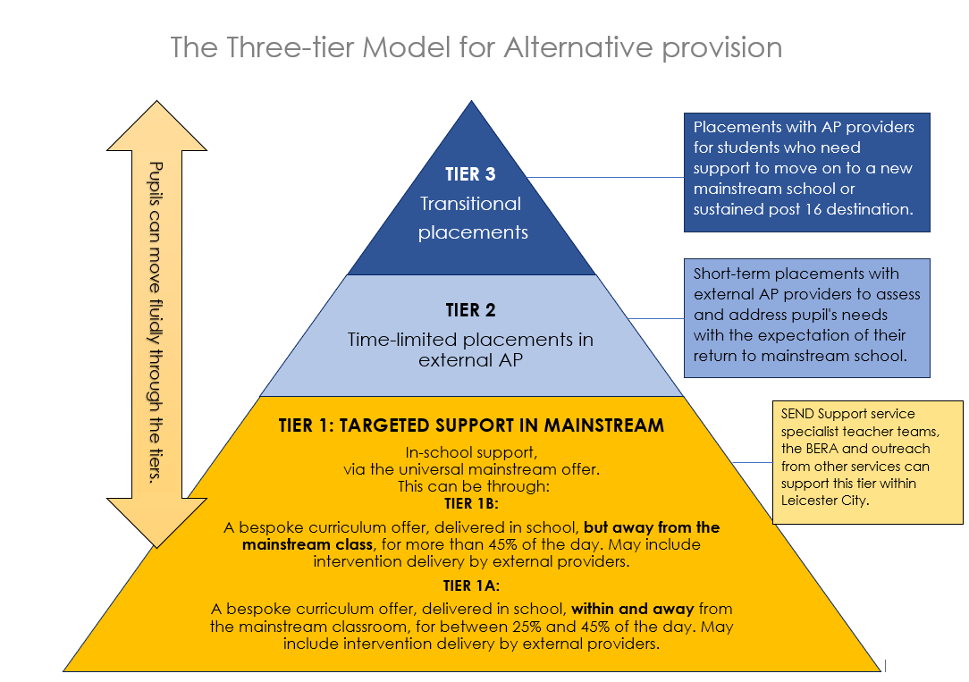

**Tier 1: Targeted Support in Mainstream Schools:**

* At this level, efforts are focused on providing additional support within mainstream schools to prevent exclusion or address early signs of disengagement.
* Strategies may include personalized interventions, mentoring, and counselling.
* The goal is to keep students within the mainstream educational environment whenever possible.

We have split this into tier 1a and 1b to reflect the graduated approach and increase in support, through the use of Internal Alternative Provision.

**Tier 2: Time-Limited Placements**

* + When students face challenges that cannot be fully addressed within mainstream schools, they may spend some time in alternative provision settings.
  + These placements are typically time-limited and designed to provide specialized support.
  + Students receive tailored education and interventions to help them overcome barriers and eventually reintegrate into mainstream education.

**Tier 3: Transitional Placements**

* + Tier 3 involves more intensive and longer-term placements in alternative provision.
  + Students who have experienced significant difficulties, such as exclusion or complex social, emotional, or mental health needs, benefit from this level.
  + The focus is on holistic support, skill development, and preparing students for successful reintegration into a new mainstream school or other appropriate setting.

These three tiers collectively contribute to a comprehensive alternative provision model, ensuring that students receive the necessary support based on their unique needs and circumstances.

**Headteacher Briefings on Change Programme Partnership AP Strand**

A series of online briefings have been set up to update Headteachers across LLR on the work of the CPP AP strand, over the remainder of this academic year. If your Headteacher wishes to attend but has not yet signed up, please ask them to do so via this [link](https://forms.office.com/e/MTDmiH0mbp). There will be more detailed updates for City SENDCos via the SENDCo newsletter and SENDCo briefings.

**The Alternative Provision Handbook**

An Alternative Provision Handbook is being developed, in conjunction with Leicestershire and Rutland, which will offer schools guidance on the commissioning, quality assurance and monitoring of Alternative Provision. We will be asking some schools to help us with this work, so that we can be confident that it is as supportive as possible. This will then be shared with all City schools before Easter. We are also producing a Directory of Alternative Provision providers across LLR, to help schools make an informed decision about the APs they commission at Tier 2.

**Internal Alternative Provision (IAP) Network Meetings (Tier 1b)**

The Primary Internal Alternative Provision network, led by Libby Smith (Head teacher of Imperial Avenue Infant school) have met twice. The aim of this network is to develop / enhance schools’ inclusive mainstream offer, through the use of an IAP (these are known by many names such as Busy Rooms, Rainbow rooms etc.) To support consistency across the City, the group have established entry and exit criteria for pupils using IAP and are working on a Quality Assurance self-evaluation form. Dates for remaining meetings are 27th January 2025, 17th March 2025, 16th June 2025, 1-3pm at New Parks House. If your school would like to be part of the network, please contact [michelle.deeming@leicester.gov.uk](mailto:michelle.deeming@leicester.gov.uk). A secondary network is planned, subject to DFE funding.

**Top up funding Element 3**

The average time for an Element 3 top up funding application to get to panel is 2 weeks and 1 week for an Emergency funding request. The QIT team are working hard to maintain this quick turnaround to ensure that schools receive funding to support CYPs with appropriate levels of need as rapidly as possible.

Funding has been extended to two years for Reception to year 10 children and young people, to support schools in recruitment and following the graduated approach. This is a pilot and the impact of this will be monitored to see if the 2-year funding will continue. Schools will be asked to complete a review after 1 year, for the funding to continue.

Panels really benefit from having a range of professionals and school-based staff as members to ensure that an informed decision can be made, and the correct amount of funding is awarded. SENDCos offer an important contribution to panels and attending a panel can be viewed as helpful CPD. If you have not sat on a panel recently and would like to do so, please email qualityinclusion@leicester.gov.uk.

As part of our commitment to responding to the needs of stakeholders, in collaboration with the Early Years Team, QIT are hosting a SENIF monthly drop in. This is online and no booking is required. Three have been held and had a positive reception so far. If you would like to attend a drop in discuss / find out more about SENIF, please request details from your EY link or the QIT team at [qualityinclusion@leicester.gov.uk](mailto:qualityinclusion@leicester.gov.uk)

**Drop in dates: 10 – 11.30am 26/02/2025, 26/03/2025, 30/04/2025, 21/05/2025, 25/06/2025, 09/07/2025.**

**Emergency Top Up Funding**

Just a reminder that Emergency funding is for CYP with **significant** SEND needs and that the application needs to have been discussed with LA SENDSS Professional(s) before submission. Criteria for funding are:

* New International Arrivals (collaboration with CPS) **DATE OF ENTRY TO UK REQUIRED**
* Crisis situation (removal from home, sudden hospital visits, life-changing incident, etc.)
* Significant escalation of behaviour (collaboration with SEMH team)
* Unidentified complex and enduring needs prior to starting school (collaboration with EYST, CPS or LCI)

Once awarded funding will last for 13 weeks with the expectation that in that time schools can consider whether they will need to apply for Standard E3. 6-8 weeks following the allocation of emergency funding, a member of QIT will be in touch to arrange a review visit with you.

**Inclusive Provision Reviews (IPR) Pilot**

An IPR is a half day visit to school by a small group of SENDSS professionals which has the following aims:

* To celebrate and share good practice.
* To develop the ordinarily available mainstream offer, in line with the Change Programme objectives.
* To provide schools with evidence of their inclusivity, via a review report that will celebrate their highlights. This can be shared with external teams.
* To provide schools with ongoing support to develop their inclusive mainstream offer, as required.

We are running a pilot with 6 schools in the Spring term. Schools have been informed if they are involved. The visits for the pilot will be undertaken by the QIT team. However, when IPRs have a wider roll-out, SENDCos and members of other SEND Support teams will be encouraged to participate in the reviews.

**Digital Whole School BERA**

In consultation with SENDCos we are developing a digital version of the Whole School BERA. This will be quicker to complete but will provide schools with an overview of the strengths and next steps of their inclusive mainstream offer. A pilot version has been tested by volunteer primary and secondary schools. They found it user-friendly and felt it provided helpful information to feed into their own internal review processes. Once fully developed, this will replace the current form and will be a key tool in the inclusive provision review process.

**BERA – Useful resources for SENDCOs**

The Quality Inclusion Team, in conjunction with other SENDSS teams have developed an area within the Extranet, which will provide SENDCos with useful resources. These will link to the different strands of the Whole School BERA and will include documents and links to resources. It is hoped this will be available on the Extranet within the next two weeks, with a link being sent to SENDCos.

**BERA Parent pathway (building parent confidence)**

The Quality Inclusion Team is working with Nayna Amlani (Local Offer and Preparing for Adulthood Lead), SENDIASS and PCF to launch a BERA pathway to support Parental understanding and confidence in SEND Process within schools and the Local Authority. We are at the beginning of this process and will provide updates soon.

**Leicester Graduated Approach Triangle**

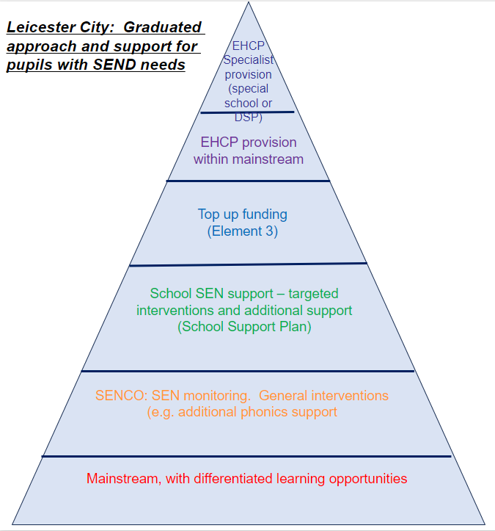

SEND Support Services have developed a Graduated Approaches Triangle Model to promote schools, colleges and settings’ understanding of how Leicester City supports inclusive provision and a graduated approach for children and young people with SEND. The document provides links and outlines support from mainstream provision, through layers of inclusion to specialist provision, including BERA, SEND SS and Alternative Provision Information. (See copy attached to email)

Each SEND Support Service Team has mapped out their support offer in relation to the Graduated Approach Triangle. (See copy attached to email)

This model is being further developed for the Local Offer to support understanding from parents and carers.

**SEND support plan**

Leicester City’s SEND Support Plan (based on the Pupil Outcome Plan (POP) widely shared across the city) is intended as a template to be used by schools to support alignment of their graduated approach with that of Leicester City Council. There is no requirement for schools, colleges and settings to use the SEND Support Plan however it may assist when:

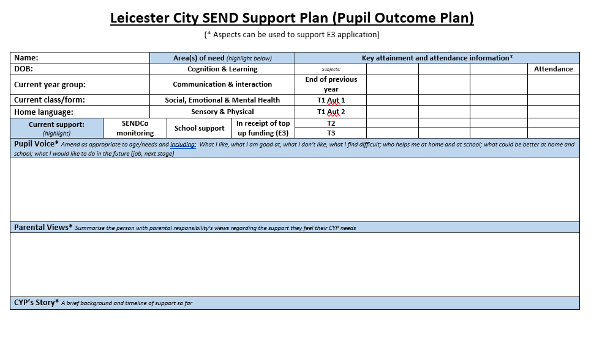

* Requesting support from SEND Support Services - LCI, SEMH, CPS, VI, HI (the Early Years Support Team have a similar but bespoke form)
* Applying for Element 3 (E3) top up funding or reapplication of funding (sections required for E3 are marked with *)
* Gathering supporting evidence of a graduated approach when applying for an EHCP assessment
* Supporting parent to understand the graduated approach and ways in which the school is supporting their CYPs needs

The form should be used in line with the schools’ processes and systems and further guidance for its use can be found on the first page of the document. Information for some sections may be collected elsewhere (e.g. intervention or school-based assessment data) and referenced in the support plan. The plan can be personalised for the CYP and for the school, setting or college.

(See copy attached to email)

**DSPs**

Designated Specialist Provision (DSP) are specialist provisions for specific types of special needs as part of mainstream school or academy within Leicester City. Our current DSPs are:

|  |  |
| --- | --- |
| **Communication and Interaction** | **Speech, Language and Communication** |
| Braunstone Frith Primary Academy  Catherine Infant School  Fullhurst Community College (Secondary)  Imperial Avenue Infant School  Inglehurst Junior School  Kestrel Mead Primary Academy  King Richard III Infant School  Orchard Mead Academy (Secondary)  Rushey Mead Primary School  Rushey Mead Academy (Secondary)  Sandfield Close Primary School  Shenton Primary School  Spinney Hill Primary School  Stokes Wood Primary School | Babington Academy (Secondary)  Barley Croft Primary School  Thurnby Mead Primary Academy |
| **Social, Emotional, Mental Health** |
| Willowbrook Mead Primary Academy |
| **Hearing Impairment** |
| Thurnby Mead Primary Academy |