Adapted with kind permission of Gateway College Leicester

Vocational Profile



Name:

Date:

This booklet will help you identify your skills, qualities, interests and aspirations.

You can use this information to help choose job sectors that you might be interested in for your work experience.

You will also use it to update your CV.

# Getting Started

This page to help get you started with thinking about you and some important things to think about when you are looking for a job or work placement.

|  |
| --- |
| **Name** |
| **Date of Birth** |
| **Address** |

|  |  |
| --- | --- |
| **Dreams and goals**  What do you really want out of life? What would be fun and satisfying to you? | **Interests**  What activities have you been most happy or enthusiastic about? Or have the most meaning to you? |
| **Talents, skills and knowledge**  What skills can you bring to the workplace? What do you know a lot about? | **Learning Styles**  What works best for you when you need to learn new tasks? |
| **Positive Personality Traits**  What qualities do you have to be successful? | **Work Experiences**  What work experiences have you had in the past? |
| **Work environment preferences**  Are there things in the environment that make it more difficult for you to work? E.g. hot/cold, noisy/quiet | **Support System**  Who do you talk to for support? What support do they give you? |
| **Specific challenges**  What challenges or inexperience do you have that could make your job search more difficult? | **Solutions and reasonable adjustments**  What solutions have worked for you? Are there any tasks or situations you should avoid to, manage your disability? |

|  |
| --- |
| **Career ideas and possibilities** |
| **Photos and pictures that show who I am:** |

|  |
| --- |
| **Why we are doing this plan:** |
|  |

# My Family and Friends

Use words and photos to describe the most important people in your life and what you do together.

|  |
| --- |
| My parents, brothers and sisters, children, partner |
| What we do together |
| How do I help my family with things we do together? |
| How does my family help me with things we do together? |

|  |
| --- |
| Other members of my family and friends |
| What we do together |
| How do I help my friends and family with things we do together? |
| How do they help me with things we do together? |

# My Places

These are places that matter to me. Some of them will be my home and neighbourhood. Some of them will be my community that I go on my own or with my family and friends. Some may be community spaces that I go with my school or service. Use words or photos to show the most important places to you.

|  |
| --- |
| Where I live |
| Where my neighbourhood is |
| What my neighbourhood is like |
| What work my family and neighbours do |

**My Community**

|  |
| --- |
| What businesses or shops my family and friends and like to use |
| What employers are near my house |
| What transport is available to me |

# My Education

This is where I go to school or college (or where I used to go). These are my favourite classes and what I have learnt to do well (like using a computer, recycling, cooking). Write or include photos of me that show me doing things independently and well.

|  |
| --- |
| What school or college I go to |
| What other schools I’ve been to and when I started and finished them |
| What subjects I study |
| What employability qualification I’ve done (like ASDAN) |
| What I am good at, at school or college |
| Tasks I can do on my own |
| Tasks I can do in a team |

# My Work Experience

These are the things I tried so far and what I have learnt from doing them. Use words and photos to show what you liked and did best.

|  |
| --- |
| My last work experience placement |
| What I liked and did best working on my own |
| What I liked and did best working in a team |
| What I did on my placement |
| How I learned to do it |
| What I liked |
| What I did best |

# My Life at Home

Each of us have favourite things we like to do and things we like to do for other people. This is what you choose to do without being asked.

You can include writing and or pictures.

|  |
| --- |
| What I choose to do at home |
| What I do for others at home |
| What I need to be able to do these things |

# My Skills

Use this page to show everything you do best. Use words and photos to show all the things you’re really good at (including knowing what to do next, finishing things, tidying things, being careful).

Also think about how best you learn.

|  |
| --- |
| **Home** (like cooking, cleaning, tidying, recycling, gardening) |
| **Community**  (like looking after a neighbour’s cat, babysitting, dog walking, helping people in other ways) |
| **Reading and numbers**  (like identifying signs, following cues and identifying money) |
| **Communication**  (like sending emails, texts, messages, speaking another language, confidence talking to others) |
| **Social**  (like meeting new people, how do I introduce myself to new people, how do I act in new situations) |
| **Work** (how do I learn new tasks, what helps me, how long do I do my favourite thing before I need a break) |

Now you are ready to take what you have learnt about yourself to start thinking about what an ideal job sector or job for you might be.

|  |
| --- |
| **Are there any specific activities you would like to try in the future?**  For example driving, making something, rewiring a plug.  Give at least three ideas of activities you might like to try |
|  |

|  |
| --- |
| **What I think might be an ideal job for me**  Give at least 3 ideas of job roles you might like to try |
|  |

# Transferable Skills

This wil help to identify skills you have that you might not realise may help you to get a job. Put a tick next to each skill you have.

Choose 10 of your skills and fill in the table explaining when you have used it. You do not need to fill in every box for each skill.

|  |  |  |
| --- | --- | --- |
| Key Skills | Business Skills | People Skills |
| Meet deadlines | Ability to delegate | Meeting people |
| Ability to plan | Customer service | Manage people |
| Supervise others | Healthe and safety | Organise people |
| Organised | Marketing or advertising | Trustworthy |
| Accespt responsibilty | Creative | Teamplayer |
| Instruct other people | Use my hands | Motivate other people |
| Want to learn and improve | Use tools | Inspire others |
| Good time management | Use machinery | Patient |
| Solve problems | Follow instructions | Friendly |
| Manage money / budgets | Research | Caring |
| Critical thinking | Design | Persuasive |
| Independent working | Stock take | Teach and train |
| Computer skills | Sell | Take orders / instructions |
| Repair or make things | Use money | Serve others |
| Driving | Explain things | Support others |
| Self motivated | Plan events | Write clearly |
| Take risks | Checking carefully | Empathetic |
| Attention to detail | Proof reading | Written communication |
| Tactful | Write information | Verbal communication |
| Make decisions | Social media | Positive body language |
| Artistic | Check quality | Listening skills |
| Musical |  |  |
| Outgoing |  |  |
| Flexible |  |  |

Where I have used this skill

|  |  |  |  |
| --- | --- | --- | --- |
| What skill have I used | School/College | Voluntary or work experience | Hobbies and interests |
| e.g. delegated | I asked my friend to do a task when we had to do some work as a small group | I asked Roshni to help fill the tea aisle at Tesco | Captain of my football team |
| 1 |  |  |  |
| 2 |  |  |  |
| 3 |  |  |  |
| 4 |  |  |  |
| 5 |  |  |  |
| 6 |  |  |  |
| 7 |  |  |  |
| 8 |  |  |  |
| 9 |  |  |  |
| 10 |  |  |  |

# Preparing your CV

List 5 **skills** that you feel you could include in your CV that an employer would like to see

|  |
| --- |
|  |
|  |
|  |
|  |
|  |

**Personal Qualities**

List 5 personal qualities that you feel you have that you feel you could include in your CV that an employer would like to see

|  |
| --- |
|  |
|  |
|  |
|  |
|  |

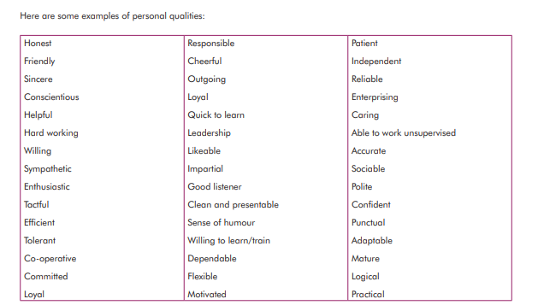

**My Hobbies and Personal Achievements**

List 3 to 5 **hobbies** that you could put on a CV

|  |
| --- |
|  |
|  |
|  |
|  |
|  |

Some ideas …

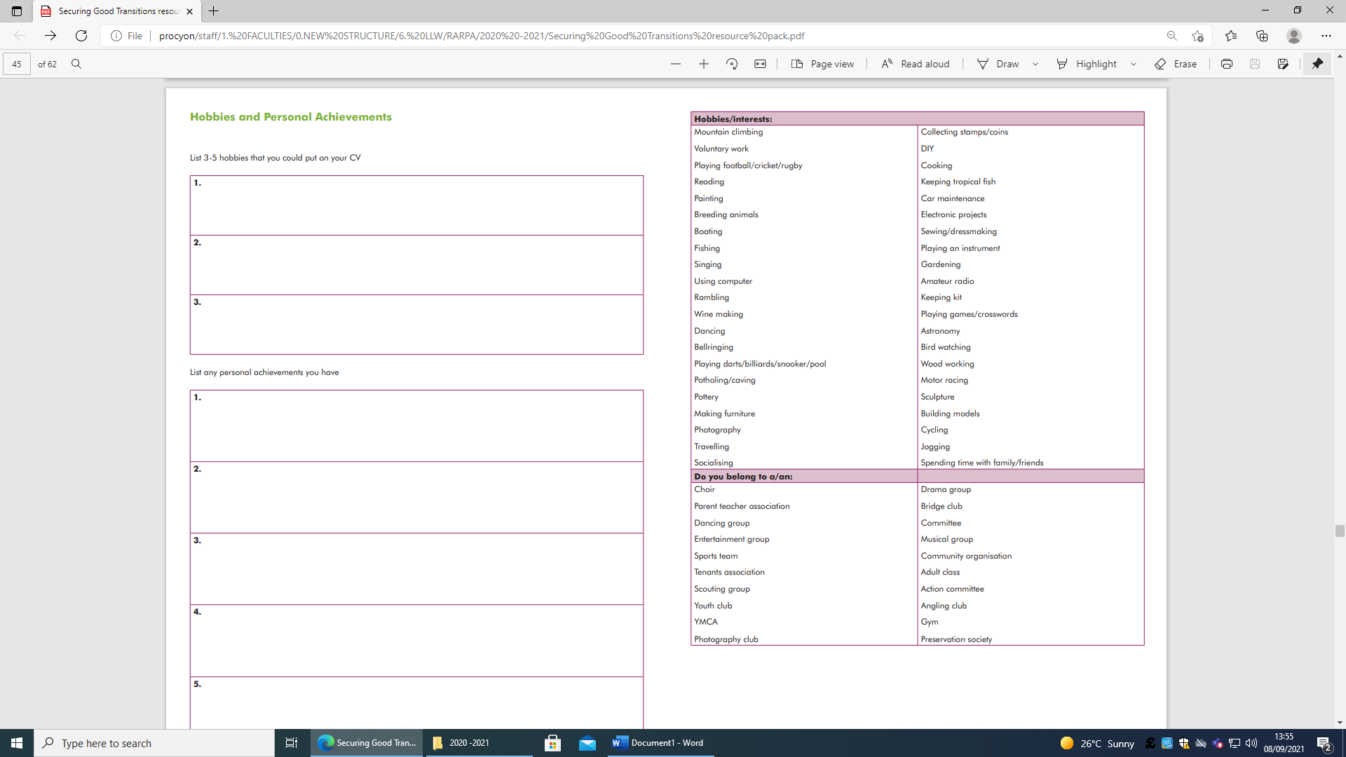

List any **personal achievements** you have

|  |
| --- |
|  |
|  |
|  |
|  |
|  |

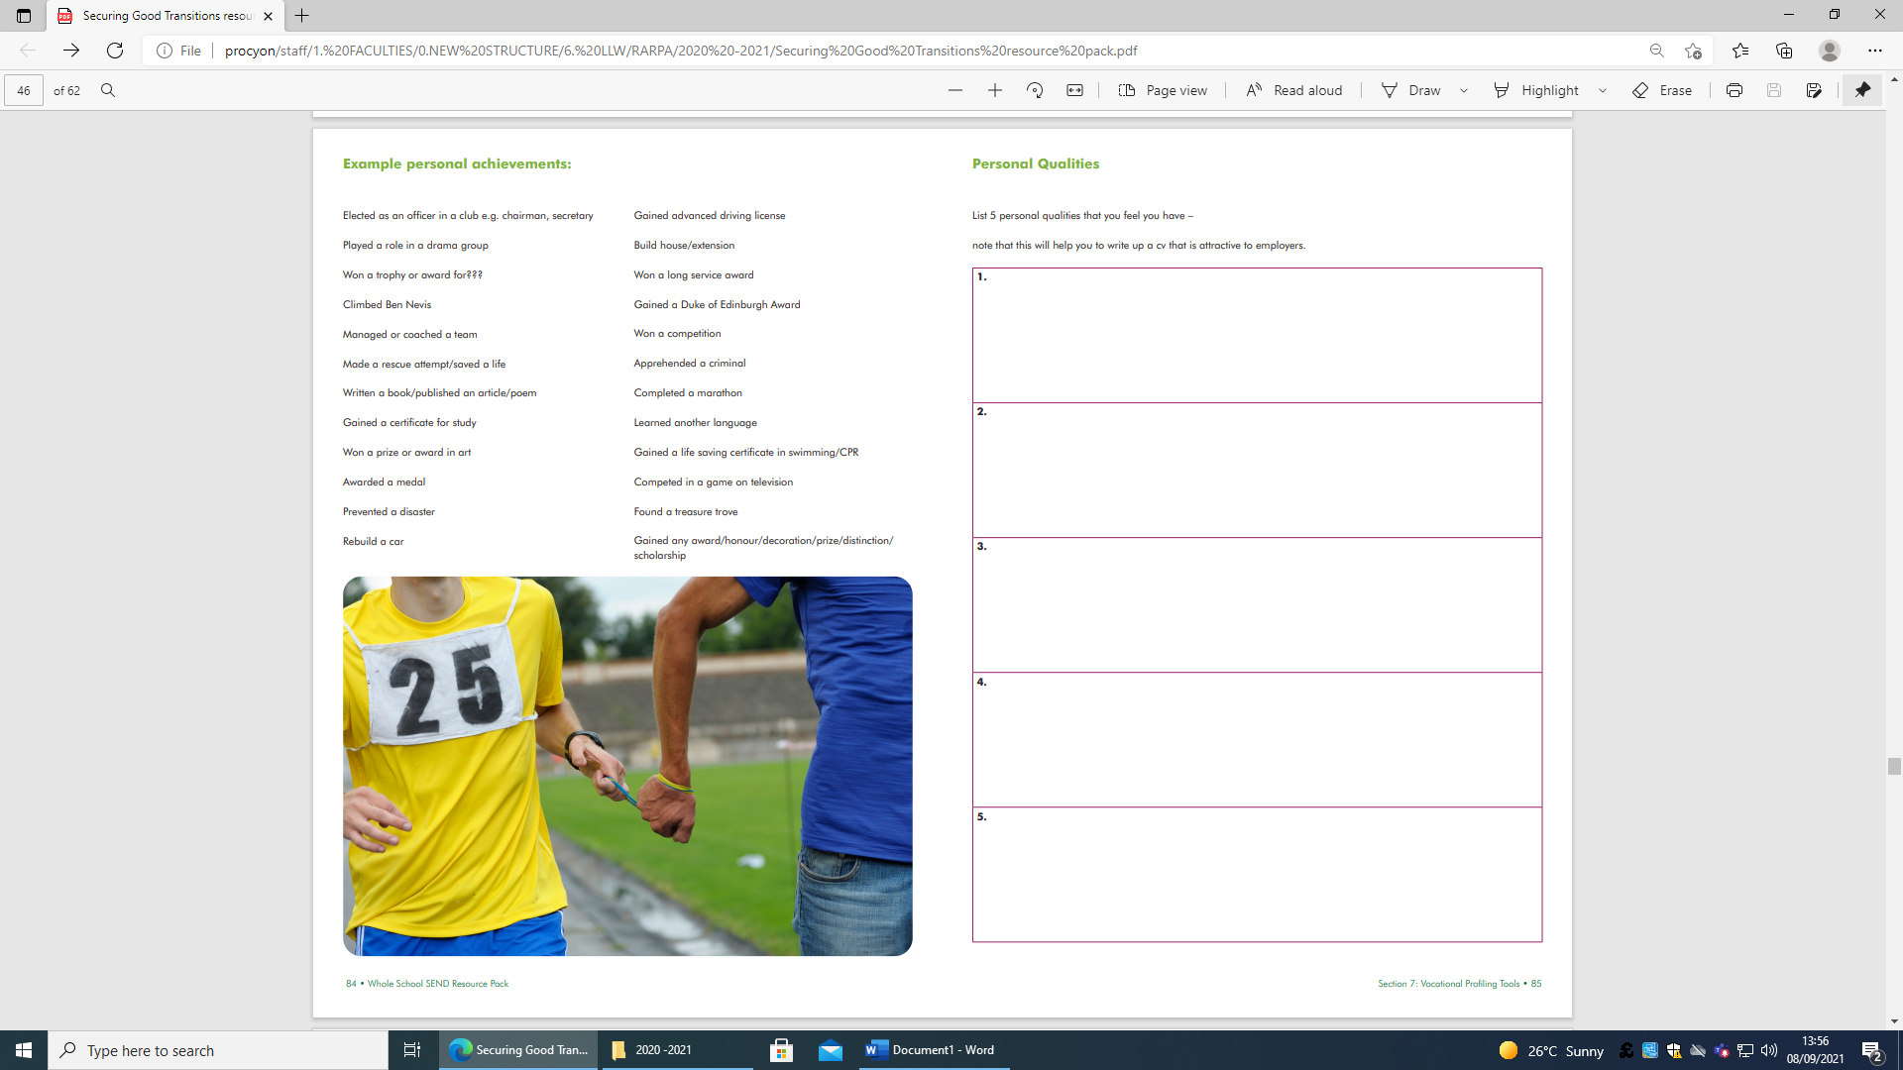

# Next Steps

Your teacher will talk to you about the next steps for you working towards your goals and aspirations.

It might be researching some job profiles in the career’s library or online.

It might be updating your CV.

It might be taking part in work experience or virtual work experience.

Or

It might be searching for job opportunities.

Your teacher will help you choose the right next step for you.