**LCI Support for Low Level Learners in Mainstream Education**



**Contents**

* Introduction
* Communication
* Curriculum (Tracking back)
* Assessment
* Special Interests
* Meeting multisensory needs
* Sensory Activity examples
* Structured teaching (TEACCH & Task Boxes)
* Typical daily schedule
* Intervention techniques that promote attention
* Resources
* Useful Websites

# Introduction:

This guide has been produced to support those adults who work with children and young people (CYP) who are performing significantly below age related expectations due to communication, interaction and learning difficulties and are in Mainstream classrooms.

Language and Communication forms a significant barrier to learning in the classroom, it is recommended that emphasis should be, in any topic, on key language and supporting the child or young person to develop their communication and inference skills.

**Taken from Primary National Curriculum framework document:**

**Vocabulary development**

*6.4 Pupils’ acquisition and command of vocabulary are key to their learning and progress across the whole curriculum. Teachers should therefore develop vocabulary actively, building systematically on pupils’ current knowledge. They should increase pupils’ store of words in general; simultaneously, they should also make links between known and new vocabulary and discuss the shades of meaning in similar words.*

**Taken from Equals Guide to the English Curriculum:**

*For children working consistently within the P scales and below age related expectations, learning to communicate effectively and appropriately will probably form the major part of any English curriculum.*

Within the Equals English documentation, we have included reference to a number of techniques that are known to be effective in Special school settings, though perhaps not so well known in mainstream settings. Imray and Hinchcliffe (2014) have identified these as Intensive Interaction, Call and Response, and Narrative and Storytelling.

**Anchor** words (words key to the topic) should be pre-taught to the CYP, with opportunities to explore the word fully using multiple exposure techniques.

Taken from **Word Aware** Teach words:

* **Symbol:** link it to visual
* **Phonology:** Clap, rhyme, initial sound
* **Semantics:** meaning (Collins Cobuild dictionary, word parts, different contexts)
* **Sentence:** put it into a sequence
* **Action:** act it out
* **Song:** song or rap
* **Word wall:** write it on the wall

**Word web template with Science example:**

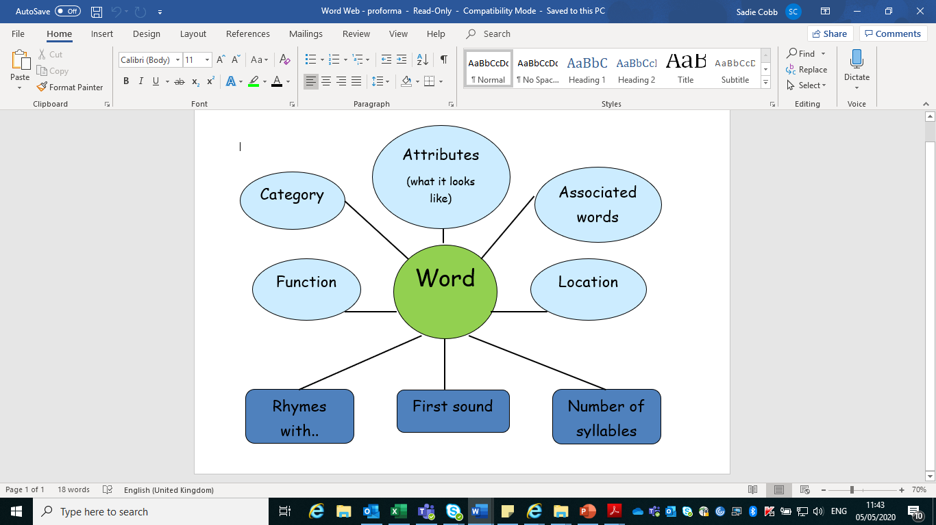

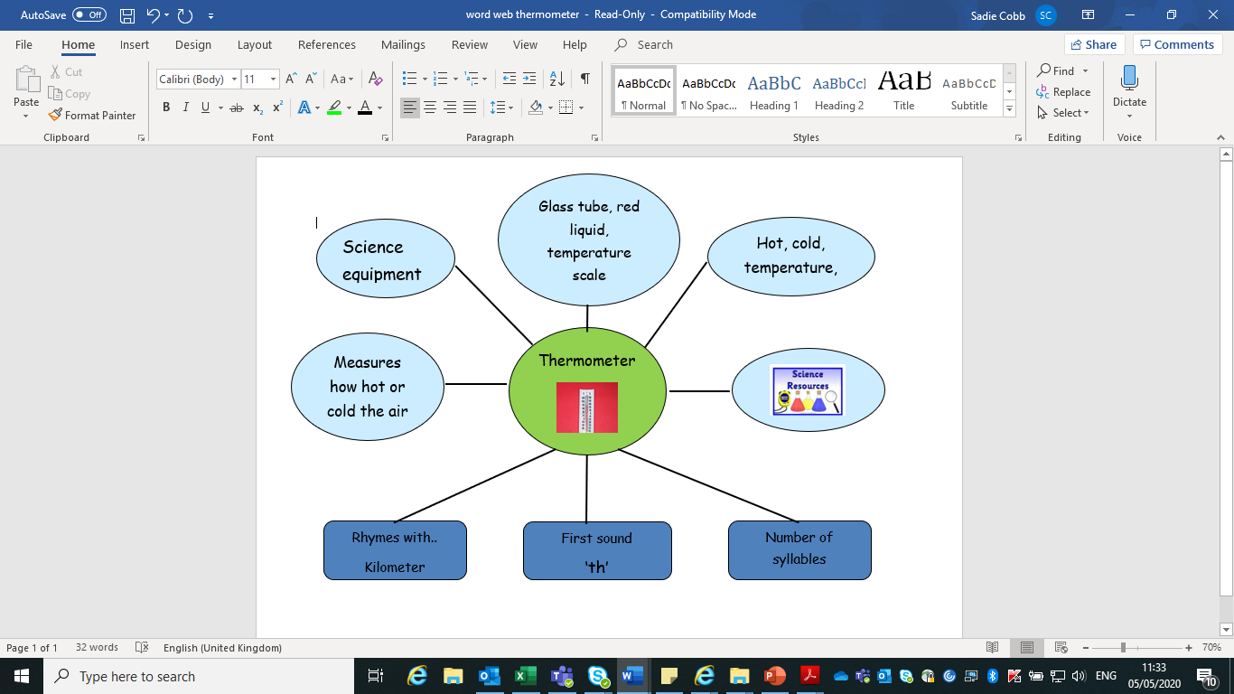

**Working with Children and Young People with Autism.**

**Communication**

Use either objects of reference, photos or symbols, dependent on the level of the learner, on a visual schedule and when communicating.

**Objects of Reference**:

An object of reference is any object which is used systematically to represent an item, activity, place, or person. Understanding real objects is the first stage of symbolic development. Therefore, using objects is considered the most concrete way of representing a word. Objects of reference are used with individuals who find it difficult to understand spoken words, signs, symbols or photographs. The object can be:

1. A real object, for example a toilet roll to represent going to the toilet or pad/nappy
2. Part of a real object, for example part of a towel to represent bath time
3. Miniature objects, for example a toy desk to represent that it is time to work
4. Abstract objects, for example a silk scarf to represent a particular person

**Examples:**

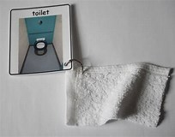 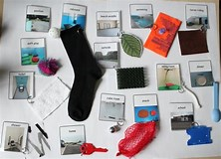

**Photo Recognition:**

For those learners who are at the photo recognition stage take photos of the rooms or activities that the learner will go to or experience.

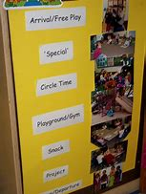

**Symbol use:**

Once a learner is able to use and respond to the photo recognition stage they can move on to Symbols to represent words. The symbols should start off large with only key needs introduced, extending to smaller symbols as the learner progresses.

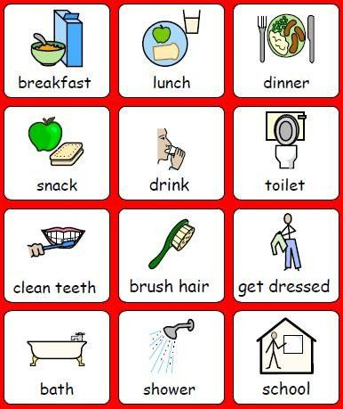

When a learner is beginning to respond to symbols then the next stage would be a symbolised timetable:

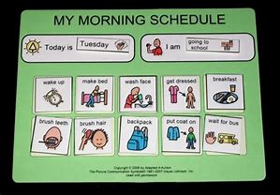

**Now and Next:**

Use a now and next board consistently so that the learner can begin to anticipate what is next. Reduce instructional language to one or two words using first then or now…next as part of the language e.g. first sitting…then drink/work etc

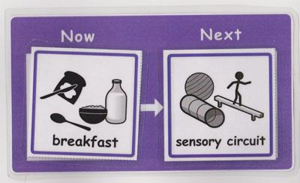 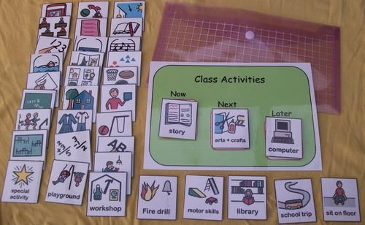

**Choice Boards/Communication Books:**

* Create a communication book and put pictures of items the learner likes/ interested in on the front. Encourage them to request by removing the picture and giving it to an adult. Respond by accepting the picture, say the word, return the picture to the book and supply the requested item. Begin with motivating items to teach them that this system is a way of requesting items they want. Over time increase the items on the communication book.

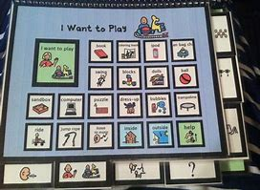 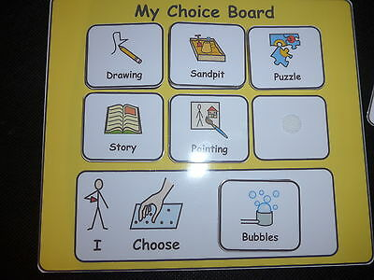

* Create 2-3 communication reasons/ opportunities in each session e.g. Place something they are interested in within sight but out of reach and encourage them to request it using the communication book / system (see above) e.g. in a clear box with a clip lid
* Continue to use their name and a key word e.g. Helen look, Helen come
* Use Makaton signs to support key words: - e.g. look, come, listen, give, more, finished, wait, now, hello, goodbye, where, who, what, good, bad, drink. Further information about ***Makaton signing available from LCI, SALT or YouTube (Makaton signs for children)***
* Provide pauses during tasks they like e.g. bubbles and wait for them to request ‘More’

**Curriculum Planning**

When planning whole class objectives, it may be necessary to ‘track back’ for those children working below age related expectations.

EQUALS offer useful guidance on what objectives and outcomes may look like for children in KS1+ working at P level.

Whilst the objective remains the same, the activities, experiences and resources have been adapted to suit the Key Stage. Example below:

**EQUALS guide to the English Curriculum for those working below age related expectations.**

**Spoken Language and Communication (i)**

**Appropriate P6 level descriptor**

**Speaking**

Pupils initiate and maintain short conversations using their preferred medium of communication.

They ask simple questions to obtain information, (for example, ‘Where’s cat?’).

They can use prepositions, such as ‘in’ or ‘on’, and pronouns, such as ‘my’ or ‘it’, correctly.

**Listening**

Pupils respond to others in group situations, (for example, taking turns appropriately in a game such as ‘Pass the parcel’).

They follow requests and instructions with three key-words, signs or symbols, (for example, ‘Give me the little red book’).

**EYFS**

**Language for Thinking:** Use talk, actions and objects to recall and relive past experiences.

**Language for Communication:** Can retell a simple past event in correct order, for example, went down slide, hurt finger and later can retell a simple story recalling events and character.

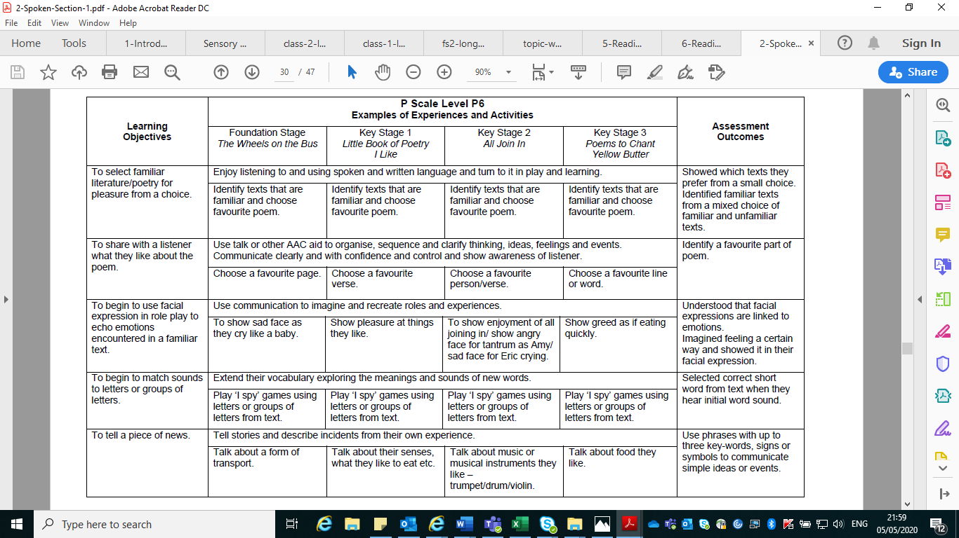

**Year 1 programme of study:**

**learning to appreciate rhymes and poems, and to recite some by heart**

|  |  |
| --- | --- |
| EYFS Reading  R6a Continues a rhyming string.  R6f Uses vocabulary and forms of speech that are increasingly influenced by their experiences of books.  R6g Enjoys an increasing range of books. | **P6** Pupils initiate and maintain short conversations using their preferred medium of communication.  **P7** Pupils use phrases with up to three key words, signs or symbols to communicate simple ideas, events or stories to others, *for example, ‘I want big chocolate muffin’.*  **P8** They link up to four key words, signs or symbols in communicating about their own experiences or in telling familiar stories, both in groups and one-to-one, *for example, ‘The hairy giant shouted at Finn’.* |

Here is an example of how the **KS2 scheme of learning: Light and Shadows** has been tracked back to **KS1** and then the PIVATS levels using the **EQUALS** curriculum objectives.

The objective language changes from *encounter, explore, participate, respond & experience* to *understand, explain, know, examine, create, investigate etc* to reflect the level the learner is at whilst the activity and outcomes are relatively similar if not the same.

For example ***all learners*** can go outside and look at shadows, ***some*** will be able to draw around them, ***some*** will experience them, ***some*** will be able to identify differences and make links to other facts they know and ***some*** will be able to categorise and predict.

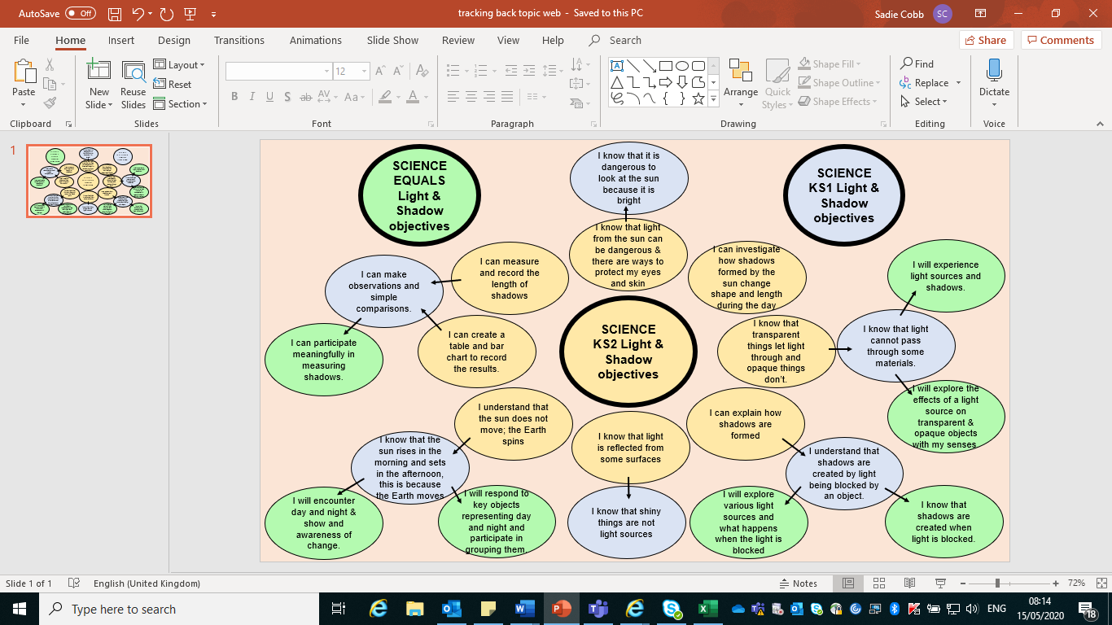

**Assessment for Low-Level Learners**

Assessment forms an important step in your cycle of SEND teaching. It is vital that you gain a broad understanding of your pupil’s abilities by either reviewing previous assessment data and targets set for them (EHCP or SEND documents) or doing your own formative assessment. Question whether previous assessments are fit for purpose as pupils can present differently in a new setting.

If you already have medium/long term targets, agree short term targets for each term, considering the small steps which pupils need to take to reach their end goal. Your school may choose to use assessment tools such as PIVATS or BSquared’s Connecting Steps, which can help staff to understand the small steps of learning required and to set targets. The AET’s Progression Framework can support in target-setting and showing progression in non-academic areas of the curriculum.

Pupil targets should be SMART (specific, measurable, achievable, relevant, time-bound) and should work towards the pupil gaining greater independence from an adult (e.g. with adult support pupil can…., with visual prompt pupil can …, with verbal prompt pupil can…). SMART targets support a sense of achievement for pupils and staff.

**Recording progress**

It is important to remember that progress may be lateral as well as linear and will look different for all learners. Capture evidence of progress through qualitative recording by making notes, using photo and video (with permissions). Remember to consider “pupil voice” by recording their responses to activities and in which activities they are most involved. Why not make a daily achievement book to support the pupil in looking back at activities in which they’ve succeeded.

**Consider:**

* How established is the skill; can they apply it accurately and consistently?
* How independent is the pupil in the skill?
* Can they use the skill widely across activities, times, with different resources and people?

Progress can also be a reduction in behaviours, which are barriers to learning and seeing more behaviours which support learning.

**Summative Assessment**

Pupils working below Pre KS standards and taking part in subject-specific learning (previously P5-8) should be assessed against Pre KS1 and Pre KS2 standards at the end of each Key Stage at primary level (standards are in Reading, Writing, Maths and Science). These are for summative assessment only and should not be used for target setting or as a curriculum.

<https://www.gov.uk/government/publications/pre-key-stage-1-standards>

<https://www.gov.uk/government/publications/pre-key-stage-2-standards>

Pupils working below Pre KS standards, not taking part in subject-specific learning (previously P1-P4 levels), should be assessed using the new Engagement Model from September 2020. This is an observational framework which uses 5 areas of focus to identify how well a pupil is working towards achieving outcomes. It supports teachers to reflect on whether they are using effective and engaging teaching.

The Engagement Model has 5 areas of engagement:

* Exploration
* Realisation
* Anticipation
* Persistence
* Initiation

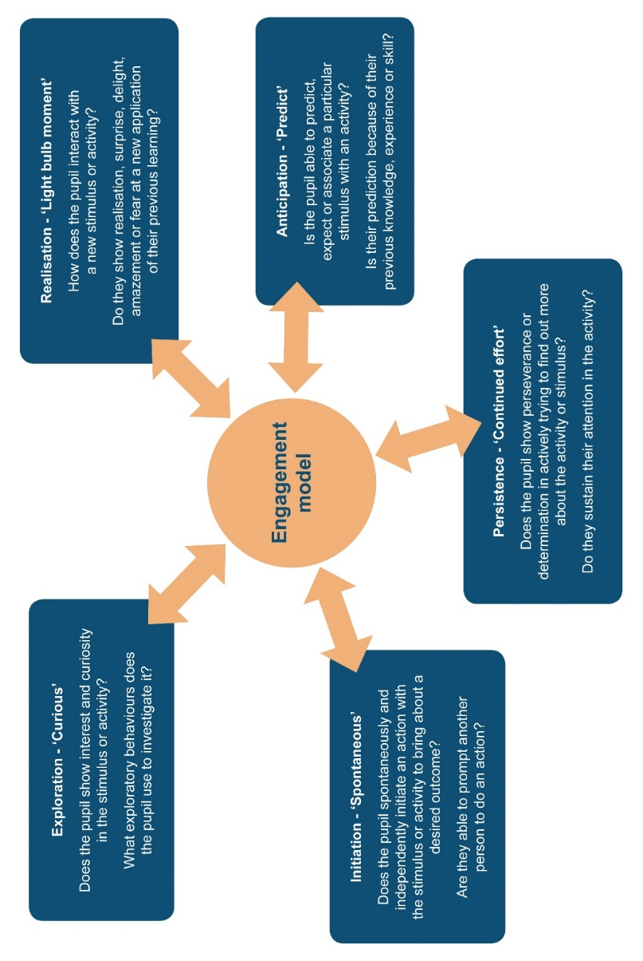

<https://www.gov.uk/government/publications/the-engagement-model>

**Special interests**

Many children and young people with autism have strong special interests, and these have been identified as one of the most powerful ways to motivate an individual. As a result, teachers and teaching assistants are well advised to incorporate them in their work with children and young people with autism.

**Using special interests**

Examples of using special interests include:

* a student’s interest as a vehicle for teaching counting (e.g., counting pictures of cars, trucks, or other motor vehicles)
* a student’s enthusiasm for water to teach self‐help skills (e.g., taking a shower, cleaning a bathtub, or washing hands)
* Using a student’s interest in cartoon characters to teach social skills

**STEPS**

The following steps can be helpful in using special interests to teach children and young people with autism:

1. Identify the student’s special interests. Teachers can develop a list of the child or young person's special interests. Observation and information from parents, paraprofessionals, or other related people can be helpful in identifying special interests.
2. Apply the identified interests of the child or young person into various forms across teaching areas. Special interests can be applied to teach self‐help skills and social, communication, or academic behaviour For example, the child who likes ladybirds can improve her reading by reading books on this topic.
3. Update the interests as they can change over time. Also, overreliance on using one special interest can decrease its effectiveness. Varying the use of special interests may keep less preferred interests still functioning as motivators.

**Examples of application in schools**

1. A pupil with autism who loves to play with water and becomes extremely excited whenever he sees bathrooms or water. When the pupil is out in the community, he always tries to find and then goes into the bathroom, including the women’s bathroom. In addition, he tries to flush every toilet and plays with water until someone stops him.
2. His teacher, decided to use his enthusiasm for water to teach various skills, including self‐help, reading, and math. For example, he learned to recognize words and icons using stories about water, weather, oceans, and fire engines (water was used to put out fires). The teacher also wrote a Social Story™ about hygiene for him emphasising all the hygiene activities that involved water
3. An older student who had a special interest in sports statistics had his P.E. teacher make him the football team’s statistician. This enhanced his social interactions because football players wanted to know their personal statistics – information that the student was eager to share. The student's literature teacher used his special interest to motivate him to read. She carefully selected stories about sports stars.
4. Having their working space transformed into a train station as the pupil had a special interest in a character (Thomas the Tank engine)

**Meeting multisensory needs**

There are eight senses, touch, taste, sight, smell, taste, proprioception, vestibular and interoception. These senses are constantly sending signals to our brain to help us process the world around us. Some children or young people can have difficulty processing these senses, they may be over or under stimulated.

**Complete a Sensory Profile**

Parents and school to identify any sensory sensitivities then make appropriate adjustments to the classroom, school environment and the individualised timetable. Children and young people may need a multisensory curriculum or sensory breaks throughout the day to support them to process the world around them.

Create opportunities for senses to be explored by setting up activities that appeal to the learner’s senses.

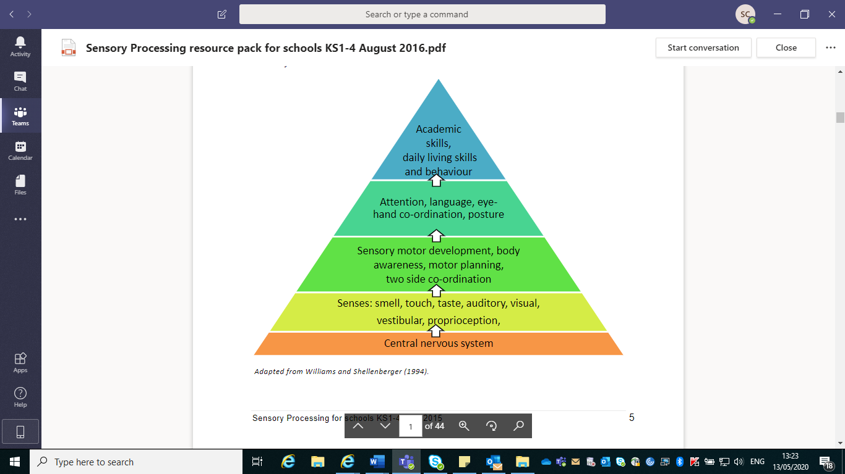

**Sensory activities**

Over the following pages there is a selection of sensory activities, the list is by no means exhaustive and all can be adapted using the resources you have available to support a learning objective and to meet the sensory needs of the child or young person.

**Sensory Toys**

Some learners enjoy playing with Sensory toys that they can watch rather than play with and get their hands dirty. A simple oil and water play bottle can be made; Fill half of the bottle with water that has some food colouring added to it. Then top up with some vegetable oil and ensure the lid is screwed on tightly (or glue shut).

[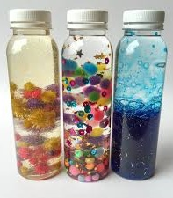](https://www.google.co.uk/url?sa=i&url=https%3A%2F%2Fwww.pinterest.co.uk%2Fpin%2F203787951866074664%2F&psig=AOvVaw2xKWTsVvspoYCun3POPqWQ&ust=1589453037297000&source=images&cd=vfe&ved=0CAIQjRxqFwoTCKDau4_UsOkCFQAAAAAdAAAAABAE)  [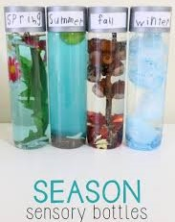](https://www.google.co.uk/url?sa=i&url=https%3A%2F%2Fmamapapabubba.com%2F2017%2F01%2F08%2Fseason-sensory-bottles%2F&psig=AOvVaw2xKWTsVvspoYCun3POPqWQ&ust=1589453037297000&source=images&cd=vfe&ved=0CAIQjRxqFwoTCKDau4_UsOkCFQAAAAAdAAAAABAL)

**Scented playdough:**

Make up a large batch of [playdough](https://www.wesco-eshop.co.uk/54604020-pack-of-play-doh-modelling-clay-2-68-kg.html) and divide it into separate bowls. Mix different ingredients into each bowl, to create easily identifiable smells, for example cinnamon, almond essence, lemon juice, vanilla essence, ginger and so on (you could also add food colouring). While the children play with the dough they can enjoy the different smells and try to guess what they are. Herbs are also a sensory addition to the playdough.

**Car wash:**

Set up a car washing station with bowls of water, soap, [sponges](https://www.wesco-eshop.co.uk/22478014-round-sponges.html), brushes, cloths, towels and a selection of [plastic vehicles](https://www.wesco-eshop.co.uk/54357020-small-metal-cars.html). The children will love playing with the soapy water, scrubbing the cars clean and drying them off again. This can also be done with dolls to explore self-care, providing toothbrushes, flannels, sponges etc.

**Mud kitchen:**

If you have the space, it’s worth setting up a permanent mud kitchen as they are very popular, particularly with children who are drawn to sensory activities. You can buy readymade mud [kitchens](https://www.wesco-eshop.co.uk/of53447-gourmet-kitchen-fridge-trio-wesco.html), or make your own by repurposing cast-offs or building from scratch. Make sure there are also plenty of [utensils](https://www.wesco-eshop.co.uk/54336171-plastic-doll-s-tea-set-kitchen-utensils-kit-wesco.html) and tools available to play with.

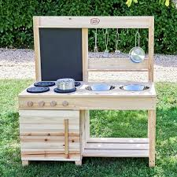

**Homemade musical instruments:**

There are lots of different [musical](https://www.firstdiscoverers.co.uk/5-best-musical-toys-early-years/) instruments that you can make with young children and creating them can be just as much fun as playing with them. Ideas include shakers (e.g. fill plastic bottles with rice or dried beans), rattles (e.g. thread buttons or beads onto some string), drums (e.g. use [wooden spoons](https://www.wesco-eshop.co.uk/21737016-maxi-pack-of-wooden-spoons.html) to beat on plastic tubs) and chimes (hang up some bottle tops or shells).

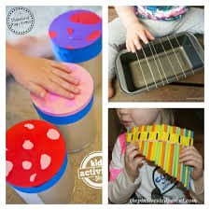

**Footprint painting:**

For this activity you’ll need a large roll of paper and some trays of paint, as well as paper towels and water on hand for cleaning the paint off the children’s feet. You could try to create a scene (e.g. [paint](https://www.wesco-eshop.co.uk/52726171-acrylic-paint-maxi-pack.html) some circles and then get the children to make footprint petals around them), or just let them go freeform. Encourage the learners to explore the paint with their body parts.



**Cornflour slime:**

This homemade slime is great to play with as it has unusual properties – it’s a cross between a liquid and a solid. In a large shallow container, mix cornflour and water until you have a slime consistency. If you punch the slime it instantly turns solid, but when you scoop some up and hold it, it will turn back into a liquid.

**Frozen toys:**

You’ll need to prepare this activity a day or two ahead. Find a large plastic box that will fit in your freezer, quarter fill it with water, put some toys in and freeze. Add three more layers, and then turn out your ice block. The children then have to get the toys out of the ice, using a selection of tools (eg spray bottles with warm water in, toy hammers etc).

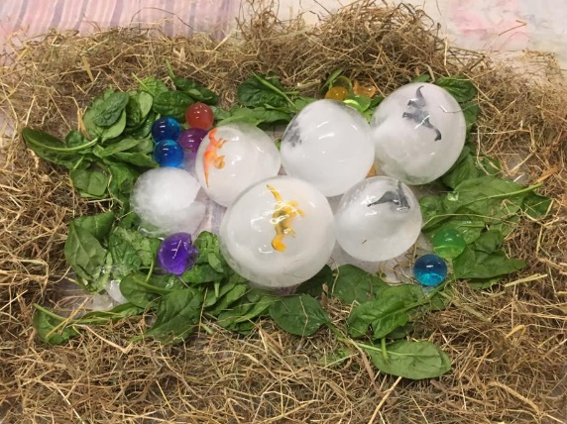

**Sand table:**

Sometimes the simplest activities are the best. Most children love playing with sand, so invest in (or build) a [sand table](https://www.wesco-eshop.co.uk/gp32975-small-sand-and-water-activities-table-wesco.html), along with a good selection of [resources](https://www.wesco-eshop.co.uk/48248171-sand-games-wesco.html) for them to play with – buckets, rakes, moulds, sieves and so on.

**Bubble snakes:**

For this activity you’ll need plastic bottles, socks and bubble mixture. Cut the bottoms off the bottles, and put the socks over the ends, pulling them all the way over the bottle and then folding them back so you have a tight fit. Dip the sock-covered end into the bubble mixture and blow through the top end to make lovely long bubble snakes.

**Structured teaching**

Structured teaching is an approach developed by the University of North Carolina **TEACCH** program, and is an approach to teaching based upon an understanding of the characteristics and learning styles associated with the nature of autism.

Structured teaching aims to teach a child how to learn in a familiar and methodical way. The environment is organised in such a way that the child is familiar with and understands what is expected of them.

Visual cues enable the child to understand what needs to be done and to focus on relevant information.

Here are some examples of the visual cues and prompts associated with structured teaching:

The child puts their own workbox on the left side and the ‘finished’ box is on the right side. When the child has completed a task, they will put it in the ‘finished box’. This reinforces working left to right.

The different coloured numbers are used to show the child which task is 1st, 2nd and so on. When the child takes the activity out of the box (previously prepared and in the correct order!) they can take the number from the wallet and match it to the number board on their right. This gives a clear visual cue of how many activities need to be done and in which order

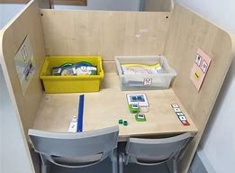 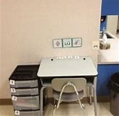

**Workstations**

1. Learners work from left to right (it’s a literacy thing).
2. Learners have a place to put their work when it’s finished (this avoids the learner taking her work apart and redoing it).
3. The system only contains the work that needs to be done (no extra pieces).
4. Work stays completed going into the finished basket (so teachers can check, and learners value their product).
5. Use nonverbal prompts only to teach the skill (makes it easier to fade support).
6. Tasks have clear beginnings and ends to the student (they have to know where to start and when it’s over)
7. The systems contain ONLY mastered work (it can’t be independent if they can’t do it on their own).
8. Students never see staff disassembling their work (it demeans their efforts).
9. They must be tasks that don’t require a partner (again, has to be independent).
10. Change the tasks at least weekly (or it gets boring).

A good example of this in action can be found at <https://youtu.be/peljI65qGrg> and at <https://youtu.be/MwBHCPbo5C8>

**Task Boxes**

A task box is a container (box) that contains all the materials needed for a learner to complete a task independently with a clear, tangible finish and reward.

**Elements of a task box:**

* The activity
* Resources
* Visual to show sequence of task
* Visual to show reward/motivator

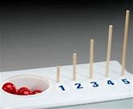 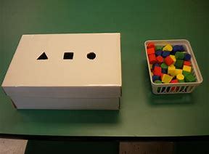 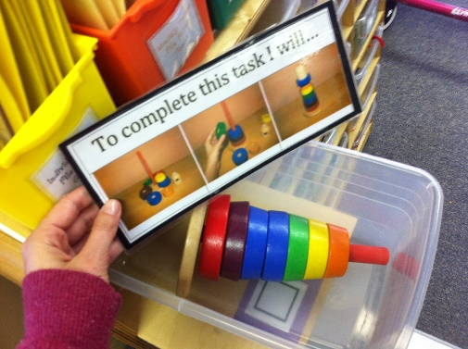

**Rewards, Motivators and Sensory breaks:**

Students may need an incentive to motivate them to complete the tasks

These could be part of an existing system or an individual one solely relating to the Task Boxes

Many learners also need sensory breaks within their learning, this should be included within the timetable.

The rewards or motivators do not need to be elaborate but should be timed and it can be helpful to use the learner’s special interests.

**Storage:**

Here are some examples of task box storage. If the school has a number of low level learners who would benefit from task boxes it may be beneficial to set up the task boxes in advance and rotate them amongst learners, over time you will have a bank of task boxes for the key learning criteria.

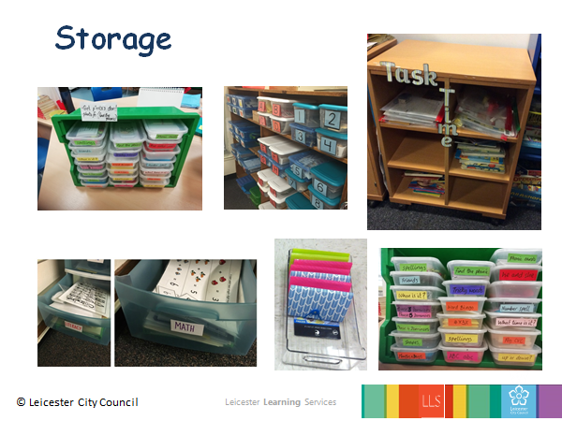

**A typical daily schedule for a low-level learner may look like this**

|  |  |  |  |  |
| --- | --- | --- | --- | --- |
| time | activity | resources | assessment | Notes |
| 8.50-9am | Hanging up coat, bag and putting on PE shoes  Coming to sit on his bean bag |  | Using visual schedule with touch prompt:  Success criteria:  No prompt  Independently following schedule |  |
| 9-9.10 | Hello time  Weather  Day of the week | Visuals: photo of who is here; what the weather is like and the day of the week | Put visuals onto a Velcro board  Success criteria:   1. Joins in song 2. Fills in gap with own name 3. Able to find and take photo of self and put it on the board 4. Able to find and put photo of weather on board 5. Able to find and put day name on board |  |
| 9.10-9.20 | Sensory:  Playdough or sand | Two colours or scents of playdough  Two colours of sand  Tray  Pouring or cutting tools | To be able to hold using a pincher grip cutting or pouring items.  Follow one key word instruction.    Success criteria:  Able to pour/cut using pincher grip  Able to follow: …. |  |
| 9.20-9.25 | Independent work:  Complete shoebox task:.  Colour in one circle | Workstation  Basket (velcroed to the table)  Shoebox task | To complete one basket task from start to finish  Success criteria  Starts and finishes shoebox task without prompting. |  |
| 9.25-9.35 | Language requesting:  Snack and drink | Choice board  Two snacks e.g. a wedge of apple and a piece of banana  A drink of blackcurrant and a drink of orange, small amount in two transparent plastic cups. | Can request using a choice board and oral language.    Success criteria:  Is able to both point and say the name of the item he wants and wait for it to be given to him.  Able to request more using a sign or oral language. |  |

**Interventions and techniques that promote attention:**

**Intensive Interaction Approach**

**Intensive Interaction (Melanie., N & Hewett, D; 1994)**

**Basic principles and strategies to use when doing Intensive Interaction**

We can use Intensive Interaction for children who we find hard to reach or socially connect with. Allow the child to engage in their play, actions or vocalisations and then ‘join in with their world’.

**Your personality (Use energy, excitement and enthusiasm – 3 Es)**

* join the child in his / her world.
* be playful
* be flexible
* make the activity fun

**Responsiveness**

* observe what it is the child is doing
* follow the child’s lead
* try and give meaning to the child’s actions and reactions (even when they are not intentional)

**Pausing**

* highlights the child’s contribution
* gives the child chance to reply
* creates anticipation and tension
* can lower arousal levels
* can help change direction

**Mirroring**

* copying what the child is doing
* copying and commenting on child’s actions
* copying and highlighting certain features
* copying and varying

**Building play sequences**

* repetition of identical actions
* linking sequences of actions
* adding drama, expectancy and tension

**Positioning**

* stay low
* move in slowly
* let the child pace you

**Your body language**

* signal your interest
* show that you are available (orient yourself towards the child, keep an open posture)
* use direct gaze and eye contact cautiously

**Get your face in the right place!**

* vary distance and orientation to see what suits the child best
* position yourself so that the child can easily see your face and its expressions (but don’t get in the child’s face)
* ‘fish’ for the child’s visual attention
* hold objects near your face
* keep hand actions near your face if possible

**Wear the right face**

* Use your face to communicate that activities are safe, interesting and enjoyable.
* Expressions may need to be exaggerated and held for more than normal
* exaggerate the focus of your attention

**Adding drama (but gently)**

* your aim is to capture the child’s attention
* slowdown, simplify and exaggerate expressions
* build up sequences with ‘pay-offs’ and vary the speed and introduce pauses

**Watch your language**

* less may be more
* start off by reflecting back the child’s vocalisations
* label actions and objects
* label intentions and feelings
* keep the tone warm and informal
* leave space for a response
* use questions and instructions very sparingly

**General tips for an interaction session**

**Use children’s narrow interests**

* Use the child’s interests as a basis for your session in order to connect with the child.
* These can also be used as motivators. Encourage your child to participate in an adult directed activity first to then receive his/her favourite activity or object of play

**Examples of children’s narrow interests**

* Repetitive & ritualistic behaviours e.g. rocking, spinning, flapping, echolalia & lining up toys.
* Fixations or obsessions e.g. ‘Thomas the Tank engine’, ‘Disney toys’, videos and books, ‘Digemons’, ‘Pokemons’, ‘Bionicles’, Transformers and other hero figures.
* Talents or special skills e.g. drawing, art, computer skills, construction etc.
* Topic talk e.g. talking at others about car mechanics, Hoovers, washing machines, fans, historical topics such as the Victorians, Vikings and Dinosaurs etc.

**Play Interaction**

***Training is available through LCI, an example of activities is below:***

|  |
| --- |
| We follow the child’s lead in their interest activities by copying their play and actions. |
| We sing interaction songs and comment on the child’s play. We sing instructions to help children follow and respond. |
| We tell stories through puppet play and create sensory story trails. We make puppet theatres and share sensory books with a reading buddy. |
| We play playground games to develop peer interaction and help the child generalise skills in the actual playground setting. |
| We play pretend games to help develop imagination and creativity. |
| We play to learn new skills through sensory play activities. |

**Links** [**https://youtu.be/A9c-WQqYUdE**](https://youtu.be/A9c-WQqYUdE)

|  |  |
| --- | --- |
| Activity | Space Bubbles |
| **Goals** | • I can stay in my personal space next to others  • I can pretend play with another person  • I can share attention  • I can respond |
| **Resources** | • Pot of bubbles  • Plastic Hoola Hoops  • Plastic coloured mats  • Music CD for ‘stop’ and ‘Go’ instructions |
| **How to play** | • Blow bubbles and talk about how bubbles pop when they collide with other bubbles  • Stretch your arms and legs to pretend to be in your space bubble.  • Use a hoola hoop to mark out the space bubble when moving in general space.  • Demonstrate that when we stand or sit too close to someone we can make the other person feel sad and our bubbles pop.  • Each child moves their own personal bubble without bumping into the space bubble of others.  • When the music starts everyone moves, when the music stops everyone stops. |
| **Extension** | • Play musical spots e.g. when the music stops the child lands on a spot. |
| **Vocabulary** | pop, disappear, gone, happy not bumping into…, feeling sad bumping into you, stop and go, bubble pot, blow, ready steady go, watch .. |

**An example activity of social play with peers and in a group**

**Tac Pac**

**Tacpac** is a sensory communication resource using touch and music. **Tacpac** helps people with sensory impairment, developmental delay, complex learning difficulties, tactile defensiveness, and limited or preverbal levels of communication.

<https://tacpac.co.uk/>

##### **Attention Autism**

‘Attention Autism’ was developed by specialist speech and language therapist, Gina Davies.

The approach is based on:

* An understanding of the ‘typical’ attention levels and development of infants
* This enables us to think about where the child is at with their attention and communication development and what to work on next.
* The common strengths of people with autism
* We know that people with autism are visual learners and have good visual skills, therefore, we should use visuals and pictures to share a message, reduce anxiety and add structure. We must also ensure we demonstrate an activity first, as well as modelling how to take part in an activity. This aids the children’s understanding of what they need to do.
* The characteristics of autism, Including difficulty with social communication, interaction, rigidity of thought and sensory processing differences.
* The knowledge that successful communication is dynamic, motivating and fun!

***As Gina says, we must “offer an irresistible invitation to learn”***

##### **The Attention Autism activity structure is divided into 4 parts:**

* Stage 1: Attention bucket (to focus attention)
* Stage 2: Attention builder (to sustain attention)
* Stage 3: Interactive game (to shift attention)
* Stage 4: Individual activities (to focus and sustain attention in a group, then transition shifting attention to individual activity and then refocus on the group)

This is a really useful video to watch

<https://www.youtube.com/watch?v=X-HZQqGz6gc#action=share>

**Ideas for Stage 1**

|  |  |
| --- | --- |
| **Bucket Time**- choose 2-3 objects to hide in a bucket/bag  **Resource Ideas** – bubbles, balloons, windup toys, push and go toys, musical toys, jack in the box, light spinners, foam rockets, musical instruments, funny glasses, party blowers, party hat, party popper, funny mask, pop up toy, pop up puppet, rice shaker etc.  During this time it may be necessary to make some of the resources yourself such as pop up puppets/toys, sock puppets, using a kitchen roll to make noisy shakers or decorate existing glasses, hats etc.  **Directions** – Sing the bucket song,” I’ve got something in my bucket, in my bucket, in my bucket, I’ve got something in my bucket I wonder what it is? (to the tune of here we go round the mulberry bush)  Gradually reveal 2-3 visually stimulating items from the bucket. Replace the lid each time.  Then say “finished” and put the bucket away and cross off the bucket picture on your wipe board/paper.  **MESSY RATING 1\*** | How to use Attention Autism to improve communication - The Autism Page How  to do attention autism |

**Music Interaction Approaches**

***Wendy Prevezer - Early Years Music Specialist at Sutherland House School***

***Eric Klein - Violinist Concept Training Centre***

* Some children prefer to sing but not speak
* Some children prefer to follow an instruction sung to them  
    
   E.g. Peter’s - interest/familiar song was ‘Bananas in pyjamas are coming down the stairs’  
  Teacher adapts to “Peter in pyjamas can you sit, on your chair”
* Videos of an individual session <https://youtu.be/pypjnC645n8>

and a video of a small therapy group <https://vimeo.com/103370829>

**Musical techniques and tips for non-verbal children:**

Following and responding to the child’s actions using an instrument or your voice

* Mirroring - Copy the child’s walking rhythm by playing the drum, stop playing drum when child stops walking, follow the child’s pace to match his/her rhythm of movement.
* Commenting- Highlight child’s actions e.g. sing “tap, tap, tap (child stamping feet), round and round (Child spinning round) and stop (child standing still)
* Vocal sounds - Make sounds like Boing, Boing, Bing, Bing, Whooo, Whoooo, La La La La, Ding Ding and Shhhhhhhhhhhhhh instead of the words. *Remember, babies use sound dialogues with their parents/carer before they learn to speak – chaining letter sounds to for words (Pre-linguistic development).

**Following & responding in conversational sound turn taking using objects & body actions:**

* Use your voice and vocal sounds by using cardboard and plastic cardboard tubes, mimic the child’s sound making, echo sounds. Engage in social exchanges for sounds through giggle people games.
* Clap, tap your hands together and stamp your feet to engage in sound body action conversations with the child, mimic the sounds the child makes.
* Use duplicate instruments, such as duplicate maracas to copy the child’s rhythm in play and vary the rhythm played, have a fun sound dialogue with the child.

**Maintain the flow of conversation:**

* Let your child take the lead
* Copy short sounds and/ or actions that your child makes instantly
* Vary the way you sing and play the instrument e.g. fast/ slow, quiet/loud etc

**Create Musical Play Routines:**

* Use short, physical repetitive games and sequences e.g. Row, row. row the boat
* Build the sequence towards a payoff, a playful climax e.g. tickle
* Pause within the sequence for the child to fill in the gap of song or anticipate the next part of the sequence
* Use simple language and familiar rhythm
* Give the child choices within the sequence

**Create Flexible Action Songs:**

* Sing along to what the child is doing (even if actions are non-intentional
* Sing along to what you do with the child
* Use the child’s name in the song
* Use repetition
* Use simple rhythms, if possible
* Label intentions, feelings and actions

**Example:**

We go up and down, up and down,  
Out and in, out and in,  
Side to side, side to side,  
Here we go again/ now we stop!

**In your sessions:**

* Consider children’s sensitivity to sounds before the session
* Always start with a hello song and end the session with a goodbye song
* Make a song choice board this could consist of a choice between song symbol cards for your child to choose from for example say Round and round the garden or Row Row your boat and wait for the child to respond
* Use large dolls. puppets, trucks, and other props to capture the child’s attention when engaging the child in songs, actions and rhymes.
* Sing songs through the puppets using a puppet voice, this can help the child feel at ease.

**Musical techniques and tips for verbal children:**

* Use circle time games for example ‘Ring-a-ring-a-roses….’, ‘Here we go around the Mulberry Bush’, ‘The farmer’s in his den’, ‘Let’s do the Hokey-Cokey etc.
* Encourage children to create their own movements to different musical instruments For example, when you hear the drum move like an elephant, when you hear the triangle move like a butterfly etc.
* Refer to the Interaction Training Resource Manual in section 15 for musical interaction games.
* Encourage children to make an action for different musical sounds they hear for example if they hear a drum being played they could pass a bean bag around the circle if they hear the triangle being played they could pass a soft ball around the circle.

* On a flip chart draw different sound markings such as spirals, straight lines, zig zags etc. Encourage children to match these markings to their own voices by varying their voice intonation and tone have a go at making sound graphs
* Use props such as large material cloths or masks, these can help overcome direct exposure to speak and lack of willingness to join in group activity.
* Encourage children to engage in simple dance sequences and shared movements to the music being played. Have fun moving to the music being played, make fast and slow movements to the music
* Play musical statues and musical code games.

**Sensory Cooking**

This is another classic process-based activity that allows an infinite variety of sensory exploration and experience for low learners.

For those wishing to equate traditional National Curriculum subjects to this document, cookery is a fantastic vehicle for mathematical thinking and scientific exploration. Depending on the cognitive abilities of the learner, just the process of baking a cake covers areas like size, quantity, position, measurement, weight, structure of properties, temperature, sequencing, cause and effect, estimation, counting, addition and subtraction, fractions, division etc. The state of the finished cake is neither here nor there – this is process based teaching and learning rather than objectives (skills) based teaching and learning - of course we can always buy a cake to eat at the end of the lesson

**Resources**

**Tracked back Science objectives example:**



# Useful websites

[**https://families.leicester.gov.uk/local-offer/**](https://families.leicester.gov.uk/local-offer/)

[**https://sendiassleicester.org.uk/**](https://sendiassleicester.org.uk/)

[**https://www.leicestershospitals.nhs.uk/aboutus/our-hospitals/childrens-hospital/children-and-young-people-with-autism/**](https://www.leicestershospitals.nhs.uk/aboutus/our-hospitals/childrens-hospital/children-and-young-people-with-autism/)

[**https://www.makaton.org/**](https://www.makaton.org/)

[**https://www.autism.org.uk/**](https://www.autism.org.uk/)

[**https://www.autismeducationtrust.org.uk/**](https://www.autismeducationtrust.org.uk/)

[**https://www.bdadyslexia.org.uk/**](https://www.bdadyslexia.org.uk/)

[**https://equals.co.uk/**](https://equals.co.uk/)