EBS Operating Procedures
Heating and cooling of schools

Contents

1.0 POLICY USE 2
2.0 PURPOSE 2
3.0 ROLES AND RESPONSIBILITIES 2
4.0 HEATING SEASON 3
5.0 HEATING AND COOLING TIMING 3
6.0 HEATING CONTROLS 3
6.1 Optimum Start-Stop 3
6.2 Weather Compensated Heating 3
6.3 Thermostatic Radiator Valves 4
6.3 Air Source Controllers and wall mounted temperature displays 4
6.4 Vent Temperatures 4
6.5 Zoned systems 4
7.0 PORTABLE HEATERS AND FANS 5
7.1 Portable Heater Usage 5
7.2 Portable Heater Requests 5
7.3 Desk Fan Requests 5
8.0 REPORTING PROCEDURE 6
9.0 REASONABLE ADJUSTMENT 6
10.0 SERVICE COMPLAINTS 6
11.0 GUIDANCE THERMOMETER 7

POLICY USE
This policy is for use in all Leicester City Council schools; however, academies are welcome to use the policy as a basis for developing their own policy. It will be used to determine the set point and usage of heating and cooling systems.

PURPOSE

Leicester City Council complies with statutory legislation by providing comfortable workplace environments. The Workplace (Health, Safety and Welfare) Regulations 1992 set particular requirements for most aspects of the working environment. Regulation 7 deals specifically with the temperature in indoor workplaces and states that:

‘During working hours, the temperature in all workplaces inside buildings shall be reasonable.’ The law does not state a minimum or maximum temperature, but the temperature in workspaces should normally be at least: 16°C. (16 degrees Celsius). Movement and circulation spaces such as corridors or stairwells will not be considered a workplace. Estates and Building Services shall endeavour to provide a temperature equal to or greater than 16°c at the point of which a workplace is open to staff which shall rise to 21°C (21 degrees Celsius) during the core times. The exception to these conditions are SEND schools, where users require an elevated ambient temperature for their general welfare.

Regulations do not state an upper temperature limit; however, Estates and Building Services will endeavour to do all that is reasonably practicable to maintain temperatures to a level not exceeding 30°C in buildings that do not have cooling provision. Buildings shall have either an air conditioning and cooling system or opening windows to help regulate temperature.
Summary of the heating and cooling temperatures.
- Heat up to 19-21°C
- SEND Schools 23-25°C
- Cool down to 24°C (if applicable)
N.B. External ambient temperatures can affect the operation of heating and cooling systems.

ROLES AND RESPONSIBILITIES
N/A

HEATING SEASON
The heating season runs 1st October to 30th April inclusive. There is no set period for cooling. Should internal space temperatures in September and May fall dramatically lower than average due to abnormal weather conditions then exceptions can be considered resulting in heating being re-activated.

During June, July, August and September heating systems may be being overhauled and maintained in readiness for the next heating season, so it will not be possible to quickly switch heating systems back on.

HEATING AND COOLING TIMING
The time set point for schools and other buildings shall be the occupancy temperature at the core teaching times, office times or other operational parameters.

For Schools this is likely to be:
- Monday to Friday 08:30 – 15:00.
- Evenings, weekends, Bank holidays in designated areas only.
- The heating systems shall be left in holiday mode or frost protection only during periods of school closure.
- Controlled extensions shall be employed to cover parents’ evenings and other after school activities. Consider local heating where practicable rather than running the whole facility.

HEATING CONTROLS

Optimum Start-Stop
Some buildings are controlled by a Building Energy Management System (BEMS) or other intelligent controls. This entails an optimum start-stop routine that calculates times for the heating to come on at full power to pre-heat buildings prior to the normal start time. These calculations rely upon both external and internal space temperature sensors being operational to enable the heating plant to start a requisite number of hours beforehand, dependent upon the environmental conditions sensed. Similarly, the heating can go into an “optimum-off” setting later in the heating day if the building is warm enough, to save energy.

Consider limiting the optimum on period to three hours on a Monday and two hours Tuesday to Friday.

Weather Compensated Heating
Most radiator circuit temperatures are controlled after occupation time by the ambient outside temperature conditions (e.g. if the outside temperature is very low, the radiator circuits will be running at their maximum; this heating flow temperature drops as the outside temperature warms up.). This is designed to compensate for building fabric losses. Many times during mild day conditions, the radiator circuits can therefore appear lukewarm or even cool and this is due to the compensation system working.

6.3 Thermostatic Radiator Valves
Thermostatic Radiator Valves (TRVs) should be considered as almost a fit-and-forget item as they can be set to regulate local room temperatures without the need for turning valves on and off. It is recommended that where adjustable TRVs are installed, they are left set in the most comfortable position for the majority of users. Users should also be mindful of this before reporting problems.

Air Source Controllers and wall mounted temperature displays
Temperature delivery may be different to any numbers indicated on wall mounted displays in an area. This does not indicate a fault but is instead a result of analysis during commissioning and operation process. In older systems a 3°C difference could be expected e.g. wall displays may indicate 23°C however the plant and equipment space temperature will be delivered to 20°C.

Vent Temperatures
Ceiling vent temperatures will fluctuate as the system compensates for the way a particular space is being used. The numbers of people in the space, activities being undertaken, heat from equipment such as PCs, the drawing in of external air to manage CO₂ levels and the ambient external temperature will affect the way the system operates. The temperature from a ceiling vent should not be taken as the temperature of the working space.

Zoned systems
Sites that have ‘zoned’ heating and/or cooling systems could have different operational timing and set points based upon the usage of each area. Staff may be expected to move to an alternate location within a building if the heating or cooling is off in their area.

PORTABLE HEATERS AND FANS

Portable Heater Usage
Portable heaters other than oil filled radiators should not be used.
- They constitute an increased fire risk to the buildings and occupants
- They can cause false temperatures to be sensed and prevent heating to be enabled or overheating a building.
- Heating can be held off due to high temperatures being sensed in buildings thus preventing heating to other occupants being enabled due to a portable electric heater being left on.
- The electrical system is not designed for heavy load use, such as portable heaters, heaters can cause overload to occur and there is a potential disastrous failure of circuits or even entire electrical systems.
- Portable heaters with fans are not permitted, for safety reasons, and authorisation should be sought from the building manager or responsible person.
- All oil filled portable heaters must have a current Portable Appliance Test (PAT) certificate. Personal portable heaters must not be brought in from home and connected to the building’s electrical system.
- Should there be a failure of heating in a building or buildings, Leicester City Council Facilities Management will endeavour to provide emergency portable heating if at all practically possible to do so.

Portable Heater Requests
If a portable heater is requested relating to individual staff needs the suitability of the work location will be considered by the requesting manager; to avoid unnecessary purchases, electrical overload and consideration of implications for general asset management. It is expected that the employee(s) have trialled or will trial working at alternative desks/ locations within the estate where appropriate

Desk Fan Requests
If a desk fan is requested relating to individual staff needs as specified at (9.0 Reasonable adjustment and in line with the dignity at work policy). The suitability of the work location will be considered by the requesting manager; to avoid unnecessary purchases, electrical overload and consideration of implications for general asset management. In rare circumstances the employee(s) may be expected to trial or will trial working at alternative desks/ locations within the estate.

If a purchase is approved and depending on the product required, the relevant team manager would hold responsibility for making an equipment purchase or providing revenue for the purchase.

REPORTING PROCEDURE
Individual spaces not attaining the minimum space temperatures should be reported to the site manager or Property Helpdesk via the building manager so that they can be investigated. EBS will aim to resolve temperature issues the same working day. Temporary heating may be provided if necessary. Should it not be possible to provide temporary alternative heating to areas following a failure of a main heating system then this will be considered a Business Continuity issue and therefore the local business continuity plan (BCP) of the service will be triggered and supported by EBS.

Reports should be made by the designated service representative (or Building Responsible Officer) only to avoid multiple service requests. Reports if not urgent should be raised on the helpdesk in the first instance or if unable to access, emailed to helpdesk.buildingmaintenance@leicester.gov.uk. Tel: 0116 454 2100.

REASONABLE ADJUSTMENT
Supplementary local heating or cooling will be made available to staff who have a specific need supported by an occupational health referral. These should be raised with the EBS following the ‘reporting procedure’.

SERVICE COMPLAINTS
Services are expected to take their own measures to deal with localised pockets of cold or heat within an office by working flexibly and using hot desks where available opening or closing window blinds to reduce thermal gain or loss. Estates and Building Services may undertake temperature and humidity monitoring at its own discretion to assist in the diagnosis of heating problems.

Updated: 1 October 2022, Lee Jowett, Sustainable Schools Manager

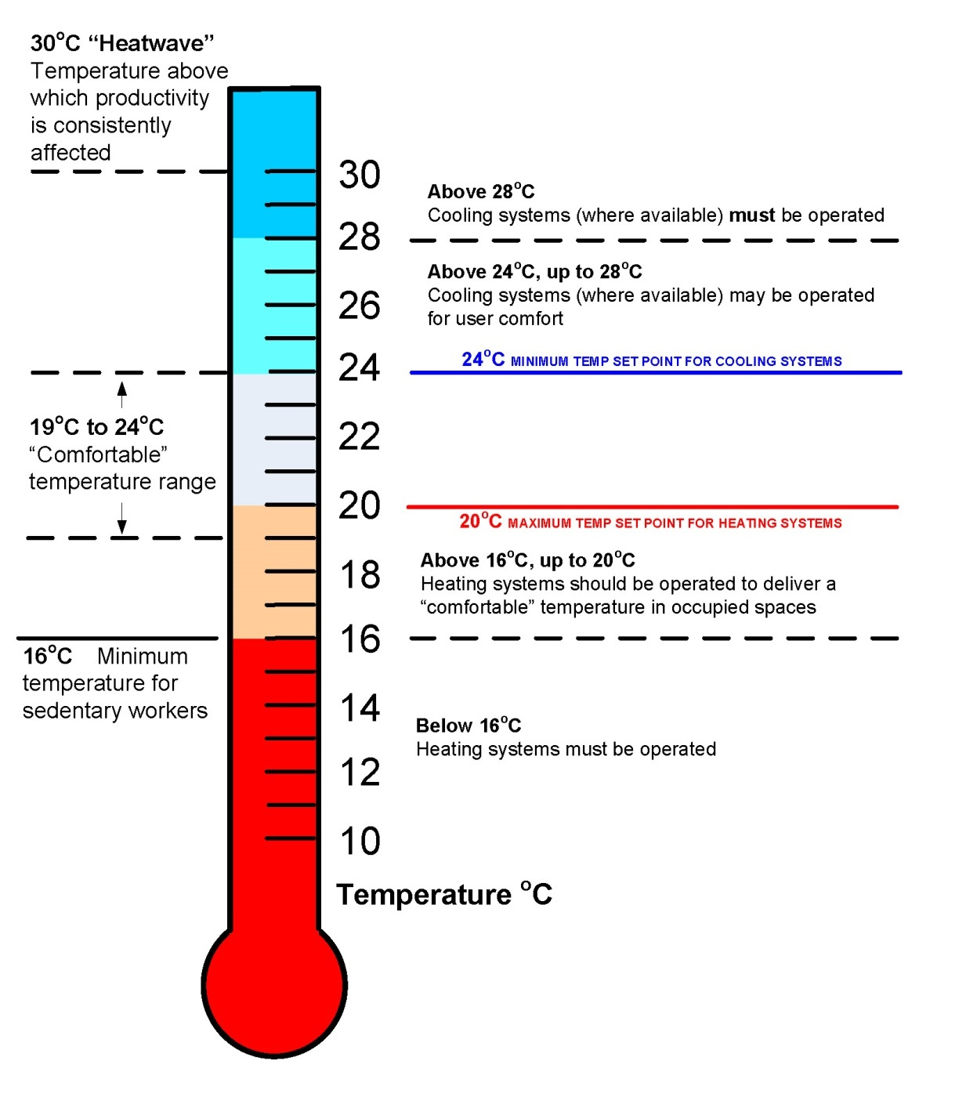
GUIDANCE THERMOMETER

