No Outsiders in our Schools – Pilot project

“Everyone is an insider, no matter what their beliefs, whatever their colour, gender or sexuality”
Desmond Tutu (2004)

Dear Head Teacher,
I am writing to you today with an exciting opportunity for you and your whole school community to take part in an innovative pilot project being facilitated and supported by Leicester City Psychology Service and Leicestershire Anti-Bullying Team from September 2017.
As you will no doubt be aware, schools and other public services are bound by our duties under the Equality Act (2010) to ensure that day-to-day, we have due regard to the need to eliminate discrimination and advance the equality of opportunity for all. This is most important in our schools, as it is through our recognition of these duties that we are able to teach a rich curriculum of social, moral, spiritual and cultural development. By doing so, we will ensure children leave primary school excited about living in a community full of difference and diversity, whether that difference is through ethnicity, gender, ability, sexual orientation, gender identity, age or religion. This is something we also know that Ofsted are particularly interested in during their inspections and will pay particular regard to the extent to which schools are now actively promoting equal opportunities for all of the protected characteristics and teaching British Values.

What is No Outsiders?
No Outsiders is a resource and framework for teaching the Equalities Act in Primary Schools, developed by Andrew Moffatt. This well regarded resource provides schools with a curriculum that promotes equality for all sections of the community and all equalities covered by the Equality Act (2010). The resource pack includes five lesson plans for every primary school year group (EYFS-Yr 6) based upon a selection of 35 picture books.

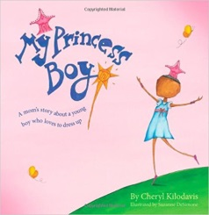
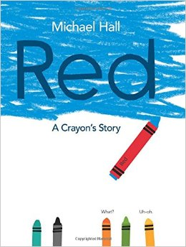

We are interested in becoming involved, what do we do now?

The impact of the No Outsiders project has been extremely well received in Birmingham City and we are looking for schools to help us pilot the approach within our Local Authority. If you would like to take part in this pilot during the academic year 2017/18, you will need to complete the attached pro forma which will assist us with the selection process. We are looking for committed and innovative schools that are dedicated to improving the celebration of equality and diversity in their school, their community and their City/County. Schools will need to have achieved the Anti Bullying Community (ABC) Award or Beyond Bullying Award and have been recently validated (within the last 3 years).

Leicester City Psychology Service and Leicestershire Anti-Bullying Team will provide your school with the training, resources and support to plan, develop and deliver the No Outsiders curriculum, all free of charge. We will also assist with the evaluation measures to assess the impact of the approach in your school.

Please send your completed pro forma and an expression of interest to participate in this pilot to phil.harbour@leicester.gov.uk by Friday 16th June.

