Directive 2006/42/EC
Machinery Working Group
Doc.WG-2013.08

HSE, Safety Unit, Priestley House, Basingstoke, RG24 9NW roger.upfold@hse.gsi.gov.uk

SLIDING POWERED GATES: Avoiding a shear gap & drawing-in risk
In late 2012 at a residential site in the UK a young child who was riding on a powered gate was carried into the gap between the gate leaf and a supporting pillar, becoming trapped and sustaining serious internal injuries which required surgery.
The child was small enough to be carried through the 144 mm wide gap between the vertical bars of the 6m long x 2m high (approx) gate leaf and the support pillar. The safety edge fitted on the support pillar failed to prevent this.
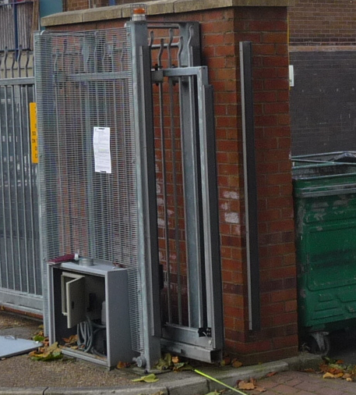
144mm
Comment
The safety edges fitted on the support columns were not best positioned to avoid the foreseeable risk from drawing-in and whole body access between the moving gate leaf and stationary parts (Note: the forces exerted by the gate in both the closing and opening directions gave results less than those specified in the current published standard EN 12453: 2000).
Standard

EN 12453: 2000 Industrial, commercial and garage doors and gates: Safety in use of power operated doors gives safety requirements for powered gates. Clauses 5.1.1.5.3 and 5.1.1.5.4 deal with the safeguarding of shearing and drawing-in points, specifying requirements for a minimum distance between passing edges of 25 mm (or rounded edges), in addition to limitation of forces at secondary edges, with a warning that “Drawing-in points cannot normally be safeguarded by limitation of forces only.” But the hazard of whole (child) body access is not currently recognised.

A formal objection has already been made (WG 2012.55) and the standard is currently being revised by CEN TC33/WG5/TG4. It is anticipated that the revised standard will fully take this issue into account.

Action

Gate designers, maintainers and owners need to be able to recognise and avoid this risk of potentially serious or fatal injury from whole body access. In the interests of public safety member states authorities responsible for market surveillance and the enforcement of safety/maintenance for powered gates, are asked to consider passing this information on, particularly to those working in the powered gate industry.

