Environmental Education Leicester
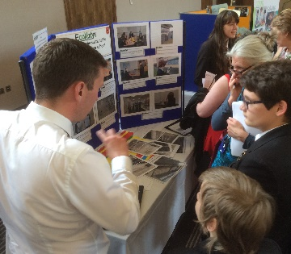
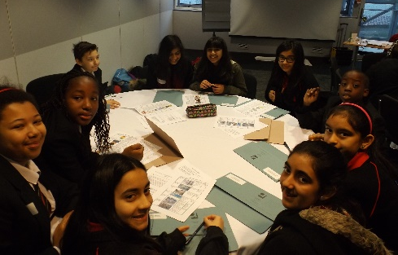

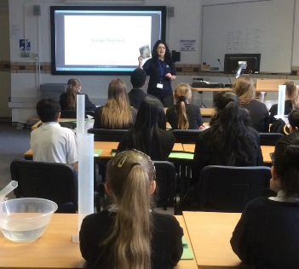

Environmental Careers Event
Monday 31 October 2016

Student name: ____________________________________________
School name: _____________________________________________

Additional copies of this booklet can be
downloaded using the QR code opposite
Introduction
During the morning, you will attend 4 different workshops. You will visit the main hall as one of your workshops where you can view the University exhibitions and join in some of the interactive sessions and experiments. Each workshop has been designed to cover a wide range of careers, so whichever workshops you attend you will receive information on at least 9 different careers. For each of the presenters there is an information sheet available online which you can access after the event. To access these scan the QR code or speak to your teacher for a paper copy.
At the end of each workshop session you will have a brief opportunity to ask questions. The information listed below can be found on the presenter information sheets, therefore I encourage you to use this opportunity to ask some different questions (some examples of questions you might like to ask can be found on the next page).
- Summary of their job
- What they do on a day-to-day basis
- Key skills needed for their job
- Qualifications A levels and GCSEs they would recommend
- Typical salary of a newly qualified entrant and what a more experienced person can expect to earn.
I hope you have an interesting morning and look forward to speaking to many of you during the day.
Lee Jowett
Environmental Education Coordinator, Leicester City Council
Timings of the day
9.15-9.30 Schools registration
9.30-10.00 Introductions and keynote speech by Martin Baxter, Executive Director of Policy IEMA (Institute of Environmental Management and Assessment) & Cllr Sarah Russell, Cabinet Lead for Children, Young People & Schools
Martin Baxter’s
profile
10.00-10.45 Workshop 1
10.45-11.30 Workshop 2
11.30-12.15 Workshop 3
12.15-13.00 Workshop 4
13.00-13.30 Lunch
Environmental and Low Carbon Sector
The low carbon sector in Leicester and Leicestershire is estimated to have a market value of around £2 billion and contains some 730 companies who employ over 8,000 people. Higher levels skills are very important. Click on the QR code on the right to find out more about this growth sector industry.
Workshop 1
Room G.01 – Ground Floor
Facilitator: Katie France is an experienced Project Coordinator responsible for delivering sustainable travel initiatives and campaigns in schools, workplaces and communities with Living Streets.
Michelle Papayannakos | Rail Safety and Standards Board | Michelle works to reduce the environmental impact of the railway industry.
Chris Walsh | Cenex | Chris is an automotive engineer designing innovative low emission vehicles of the future.
Rebecca McLean | Sweco UK | Rebecca is employed by Sweco, a large European engineering consultancy involved in designing infrastructure projects and cities of the future. Rebecca specialises in air quality.
Some questions you might want to ask
- Which aspects of your job do you most/ least enjoy?
- What do you feel makes your job worthwhile – what do you feel you have achieved so far?
- Where do you feel you want to be in next 5 years?
- Do you think the number of jobs in your profession will continue to grow?
- Does your job reflect the subjects you most enjoyed at school?
Notes
Workshop 2
Room G.02 – Ground Floor
Facilitator: Judith Payne is the STEM Manager at the Leicestershire Education Business Company. LEBC create links between business and education so that young people can learn more about business and working life.
Liz Penfold | Walkers Snack Foods | Liz finds ways to reduce energy and water used by Walkers Snack Foods in their factories.
Samira Nikzad | Pick Everards | Samira works with architects and engineers to improve the environmental performance of building designs.
James Upstill-Goddard | Responsible Solutions | James advises different construction companies to help them improve their environmental performance. This includes practical projects, training and research.

Some questions you might want to ask
- Which aspects of your job do you most/ least enjoy?
- What do you feel makes your job worthwhile – what do you feel you have achieved so far?
- Where do you feel you want to be in next 5 years?
- Do you think the number of jobs in your profession will continue to grow?
- Does your job reflect the subjects you most enjoyed at school?
Notes
Workshop 3
Room: G.04 Presentation Suite – Ground Floor
Facilitator: Anna Dodd is the Environment Team Manager at Leicester City Council, she works corporately to help the council and the wider city become more sustainable.
Conor McCone | Skanska | Conor works in the construction industry on high profile construction projects, to identify environmental solutions during construction.
Zara Rostance | Atkins | Zara is an environmental scientist working in the design office and on construction sites.
Don Munro | Munro + Whitten | Don is a landscape architect with his own practice. He designs new landscapes for people and wildlife, in urban and rural areas.

Some questions you might want to ask
- Which aspects of your job do you most/ least enjoy?
- What do you feel makes your job worthwhile – what do you feel you have achieved so far?
- Where do you feel you want to be in next 5 years?
- Do you think the number of jobs in your profession will continue to grow?
- Does your job reflect the subjects you most enjoyed at school?
Notes
Workshop 4
Room: Rutland Suite – First Floor
Facilitator: Mike Colechin is Partnership Manager at the Energy Technologies Institute. The institute works to accelerate the development of low carbon technologies.
Richard Smith | BBC | Richard works to reduce the environmental impact of the BBC’s buildings and programme production.
Sandra Lee | University of Leicester | Sandra works to reduce the environmental impact of the University including education, building use and student lifestyles.
Luke Jackson | Nottingham City Council | Luke is an energy manager currently working on renewable energy projects in Nottingham. Previously he worked for the Olympic Delivery Authority.

Some questions you might want to ask
- Which aspects of your job do you most/ least enjoy?
- What do you feel makes your job worthwhile – what do you feel you have achieved so far?
- Where do you feel you want to be in next 5 years?
- Do you think the number of jobs in your profession will continue to grow?
- Does your job reflect the subjects you most enjoyed at school?
Notes
Marketplace: Universities and Employers
Room: Attenborough Hall – First Floor
- Brooksby Melton College
- Coventry University
- De Montfort University
- Loughborough University
- Nottingham Trent University
- University of Keele
- University of Leicester - Department of Chemistry
- University of Leicester - Department of Geology
- Soil Association Food for Life
Notes
Further notes

