Fun, practical and curriculum-relevant
outdoor learning INSET

Wednesday evenings in Leicester

Just £10 per session per person

Anyone involved in education will be welcome
including teachers, LSAs/TAs, support staff, curriculum area coordinators, governors, students
and volunteers.

Environmental Studies Ltd is a local education organisation delivering Forest School programmes, curricular outdoor learning sessions, John Muir Awards and ABC qualifications to Leicestershire schools, as well as Forest School practitioner training.

INSET is delivered by a Forest School trained primary teacher with a wealth of experience in the classroom and a range of outdoor settings.

To book a place, please add your name to the attached sheet.

Office staff: when names have been collected, please e-mail details or a scanned copy to amsavage@environmentalstudies.biz or post to Unit 12b, Faircharm Industrial Estate, Evelyn Drive, Leicester, LE3 2BU as soon as possible. More details of where to meet, what to bring and how to pay will follow after booking. Thank you.

Inspiring young people to take steps towards a positive future
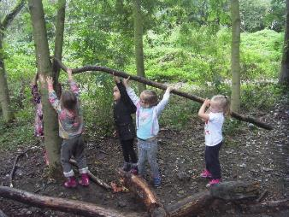
What is Forest School? 20.4.16

FREE INFORMATION SESSION!
Discover why this exciting intervention is sweeping the nation and what makes Forest School different from other forms of outdoor learning. We’ll explore the benefits and how you might go about starting it in your school.

12b Faircharm Industrial Estate 4 – 6

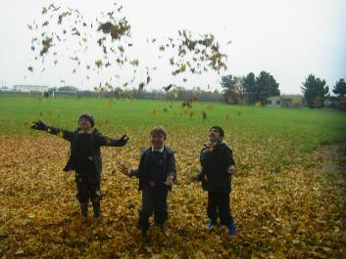
Story making 27.4.16

Develop your confidence in telling stories from memory and using the natural world to enhance your storytelling.
Get your young learners making and telling stories through fun games to develop literacy and confidence.

Aylestone Meadows 4 – 6

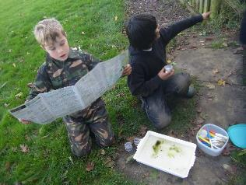

Muddy maths 4.5.16

Discover a host of great ideas for engaging children in maths. Take the curriculum outdoors at all ages and levels to enthuse your kinaesthetic learners. The activities will be relevant to number, measurement, geometry, ratio and proportion and statistics.

Aylestone Meadows 4 – 6
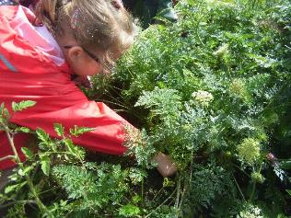

Growing with children 11.5.16

Find out how to make the most of a very small gardening area or even pots on the window sill.
Plant your own pizza to take home and have a go at a few child-friendly horticultural techniques to develop personal skills and curricular knowledge of living things.

Braunstone Skills Centre 4 - 6

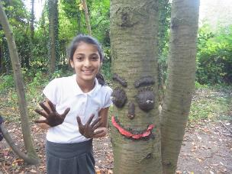
Wild Art 18.5.16
Deliver inspirational art lessons for all ages with almost no clearing up! Find out how to make beads from twigs, natural paints, mud sculpture, photo frames, basic willow structures and many other muddy masterpieces. Have a go and be inspired. No artistic confidence necessary.
Aylestone Meadows 4 – 6

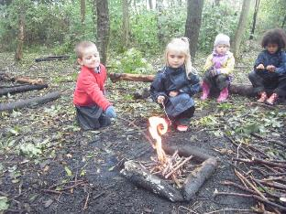
Fire! 25.5.16

- Get confident in lighting and using fire
- Encouraging children to use fire safely
- How fire-making supports curricular learning and social development
- Outdoor cooking ideas
- Fun ideas for follow-up activities and curricular links
- Roast marsh mallows!

Aylestone Meadows 4 – 6

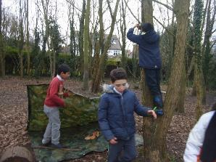
Survival shelters 8.6.16

- How den-building supports curricular learning and social development
- Basic techniques with sticks and tarpaulins
- Handy, cheap equipment
- Hone your own skills in case you’re ever shipwrecked/a contestant on “The Island!”
- Plan and deliver inspirational DT units

Aylestone Meadows 4 – 6

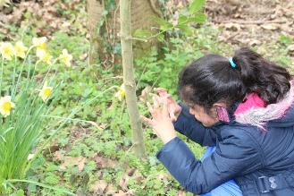

Environmental exploration games 15.6.16

Join in and learn a host of fun, educational games which explore the natural environment. Encourage pupils to awaken their senses, learn about food chains, observe properly, use strategy, improve motor skills and feel a connection with the world around them.
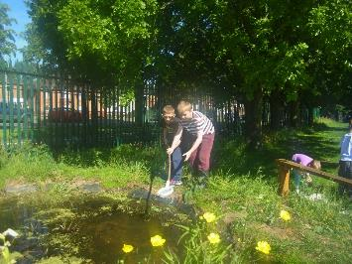
Pond dipping 22.6.16

- Improve your mini-monster ID skills
- Pond safety
- What to buy and how to cheat
- Pond critters’ place in the new curriculum
- Engaging ideas for fun follow-up activities
- Creating and maintaining a school pond

TBC 4 – 6

Marvellous mini-beasts
Part 1 29.6.16
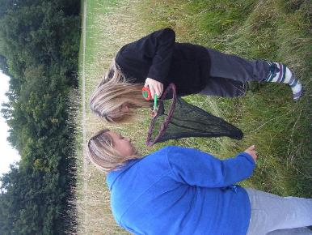
Part 2 6.7.16

This topic will be delivered over 2 sessions as there is so much to cover

- Tried and tested techniques for encouraging children to find tiny creatures
- Mini-beasts and the new curriculum
- Great ideas for engaging preparation and follow-up activities
- Improve you own ID skills and confidence
- Gross facts to get children hooked
- Get stuck in and see what you find
- No obligation to handle creatures!

Aylestone Meadows 4 - 6

sdf

Theme, date and cost | Time, place and cost | Please write your name here if you’d like a place booked for you.
20.4.16  What is Forest School?  FREE | 4 – 6  12b Faircharm Industrial Estate  Evelyn Drive  Leicester  LE3 2BU
27.4.16  Story  Making  £10 pp | 4 - 6  Aylestone Meadows  Meet at Canal Street car park  Leicester  LE2 8LX
4.5.16  Muddy  Maths  £10 pp | 4 – 6  Aylestone Meadows  Meet at Canal Street car park  Leicester  LE2 8LX
11.5.16  Growing with children  £10 pp | 4 – 6  Braunstone Skills Centre  Fulhurst Avenue  Leicester  LE3 1BJ
15.5.16  Environmental exploration  games  £10pp | 4 – 6  Braunstone Skills Centre  Fulhurst Avenue  Leicester  LE3 1BJ
18.5.16  Wild Art  £10 pp | 4 – 6  Aylestone Meadows  Meet at Canal Street car park  Leicester  LE2 8LX
25.5.16  Fire!  £10 pp | 4 - 6  Aylestone Meadows  Meet at Canal Street car park  Leicester  LE2 8LX
8.6.16  Survival shelters  £10 pp | 4 – 6  Aylestone Meadows  Meet at Canal Street car park  Leicester  LE2 8LX
22.6.16  Pond dipping  £10 pp | 4 - 6  A pond in Leicester TBC
29.6.16 and 6.7.16  Marvellous minibeasts  Part 1&2  £20pp | 4 – 6  Aylestone Meadows  Meet at Canal Street car park  Leicester  LE2 8LX

